Forms, MOAs and Appendices Contents

IX-1 APPLICATION FOR SABBATICAL LEAVE 97

IX-2 FMLA INSTRUCTIONS AND REQUEST FORM 98

X-G1 STEP ONE COMPLAINT 102

X-G2 ASSOCIATION EVIDENCE 103

X-G3 MANAGEMENT EVIDENCE 104

X-G4 STEP ONE DECISION 105

X-G5 STEP ONE APPEAL TO MEDIATION 106

X-G6 NOTICE TO MEET WITH A MEDIATOR 107

X-G6a POSTPONEMENT OF MEDIATION 108

X-G7 CONCLUSION OF MEDIATION 109

X-G8 ARBITRATION APPROVAL REQUEST 110

XII - 1 WORKLOAD REDUCTION WAIVER FORM 111

[XII-2 112](https://livemiddlesexmass-my.sharepoint.com/personal/liusally_middlesex_edu/Documents/Desktop/2023%20-%202025%20DAY%20Forms%20-%20Final%20-page%20number.docx#_Toc203647004)

XIII-E1 Student Evaluation Form 114

XIII-E2 CHECKLIST FOR COURSE MATERIALS 116

XIII-E3 PROCESS FOR CLASSROOM/INSTRUCTIONAL OBSERVATION 117

XIII-E4 STUDENT ADVISEMENT LOG 119

XIII-E5 COLLEGE SERVICE ACTIVITIES 120

XIII-E6 FULL-TIME FACULTY SUMMARY EVALUATION 121

XIII-E7 PROFESSIONAL STAFF POSITION DESCRIPTION 123

XIII-E8 PROFESSIONAL STAFF SUMMARY EVALUATION 124

XIII-E9 PART-TIME FACULTY SUMMARY EVALUATION 126

XIII-E10 PART-TIME PROFESSIONAL STAFF SUMMARY EVALUATION 129

XX-1 DEPARTMENT CHAIR/CURRICULUM COORDINATOR (PROGRAM) EVALUATION FORM 131

XX-2 DEPARTMENT CHAIR (WORK AREA) EVALUATION FORM 133

XXI-1-CLASSIFICATION APPEALS: NEW HIRE NOTICE TO UNIT MEMBERS 135

XXI-2-CLASSIFICATION APPEALS: Point Calculation Request for Review 136

XXI-3-CLASSIFICATION APPEALS: Point Calculation and/or Classification Appeal Form 137

XXI-4-CLASSIFICATION APPEALS: Classification Placement Request for Review 138

New Hire Table 1: Initial Classification Placement for New Full Time Faculty and Faculty Transfers 140

New Hire Table 2: Initial Classification Placement for Full Time Unit Professionals, Reclassifications* &Transfers 141

MEMORANDUM OF AGREEMENT NO. 1: COST SAVINGS OPTIONS 143

MEMORANDUM OF AGREEMENT NO. 2: CAS RESOLUTION 146

Written Request to Accrete Position into MCCC Day Unit 158

College’s Response to Written Request to Accrete Position into MCCC Day Unit 159

Accretion Appeal to Joint CAS Committee 160

Decision of Joint CAS Committee 161

MEMORANDUM OF AGREEMENT NO. 3: INDIVIDUALIZED INSTRUCTION SPECIALISTS 162

Appendix A: Principles Statement on Student Learning Outcomes and Assessment 163

Appendix B: Salary Grid(s) 164

APPENDIX B1: Memorandum of Agreement – Part-Time Salary Grid 203

Appendix C: Prior Learning Assessment Student Portfolio Evaluations 206

Memoranda of Agreement – 2021 – 2023 Department Chairs/Curriculum Coordinator/Program Coordinators - 20.11 Compensation 206

APPENDIX D: CRITICAL THINKING INTENSIVE COURSES 207

Appendix E: Memorandum of Agreement on the Joint-Labor Management Committee on Distance Education 208

**IX‑1**

# IX-1 APPLICATION FOR SABBATICAL LEAVE

Name __________________________________________________________________

­

College__________________________________Work Area_______________________

Number of years of seniority in the collective bargaining unit________________________

Number of years since last previous sabbatical___________________________________

Check the type of sabbatical for which you are applying:

( ) Half year leave at full salary

( ) Half year leave at half salary

( ) Full year leave at half salary

( ) Full year leave at half workload at full salary

( ) Full year leave at half workload at half salary

Date on which proposed sabbatical would begin __________________________________

Use the rest of this form and/or a separate sheet appended to this form to answer the following questions:

A. What activities will you do during the proposed sabbatical leave and what goals are these intended to achieve?

B. How will the proposed sabbatical meet the following criteria listed in section 9.01I2 of the collective bargaining agreement?

The following criteria shall be considered in determining who shall be granted for sabbatical leave:

(a) That the objectives of the sabbatical leave, if attained, would substantially contribute to the professional growth of the unit member.

(b) That the objectives of the sabbatical leave, if attained, would assist the unit member in substantially contributing to institutional needs and attainment of institutional purposes.

(c) That the unit member has the ability to achieve the goals of the project or plan based on the unit member’s past experience and formal educational background.

(d) That the attainment of the objectives of sabbatical leave as proposed are realistic in terms of time, costs, and other related variables.

(e) That there exists independent financial support from other funding sources concerned with the proposed plan or project where College funding sources are otherwise unavailable.

**IX‑2**

# IX-2 FMLA INSTRUCTIONS AND REQUEST FORM

Request for Medical Leave that may be protected as FMLA

or as a request for contractual sick leave

**Potential FMLA Leave** - The Human Resources Office has been informed that you have a medical need for leave that may be due to a serious health condition of an employee. Accordingly, if you believe that you may be eligible for FMLA leave designation and/or are requesting FMLA leave, Form WH-380-E is located at <http://www.dol.gov/whd/forms/WH-380-E.pdf> . If you would like the college to mail a copy of the form to you, please let us know. In lieu of the WH-380-E form, you may also use the attached abbreviated form entitled “Instructions to Health care Provider”.

To request FMLA leave, Form WH-380-E, or the attached abbreviated form entitled “**Instructions to the Health Care Provider”** (which was agreed to as a substitute by the MCCC and the Employer) should be provided to your Health Care Provider for completion and return. You have fifteen (15) calendar days to return one of the completed forms. Your Health Care Provider will either complete one of the two forms or provide appropriate medical documentation to support any request for FMLA leave. Note there are other forms available on the Federal website for different types of leave such as that for a family member or for leave related to military service: <http://www.dol.gov/whd/fmla/2013rule/militaryForms.htm>

**Contractual Medical Leave Requirement** – Even if you do not believe your sick leave request would qualify as FMLA protected leave, please have your health care provider complete the attached physician's certificate entitled “**Instructions to the Health Care Provider”**, proving the necessity of such absence for the medical leave you are seeking. As set forth in Article 9.01, the certificate must be filed within seven (7) calendar days of this request, or your absence may be applied at the discretion of the College as absence without pay.

If you need additional time for your health care provider to complete the required information, please contact the Human Resources department to request an extension of time to provide the information.

Please note, the FMLA allows employers to charge your leave concurrently to sick leave under the collective bargaining agreement and to FMLA if you are entitled to the twelve-week unpaid leave allowed for certain employees under FMLA for a “serious health condition.” If FMLA applies, an employee must first use all accrued sick leave and then, if eligible, available sick leave bank days, as part of their twelve-week FMLA leave prior to being placed on unpaid FMLA leave for the remainder of their 12 week FMLA leave period, if any.

**IX‑2**

**INSTRUCTIONS to the HEALTH CARE PROVIDER:**

Your patient _____________________________has requested leave from________________________

Community College. Answer, fully and completely, all applicable parts. Several questions seek a response as to the frequency or duration of a condition, treatment, etc. Your answer should be your best estimate based upon your medical knowledge, experience, and examination of the patient. Be as specific as you can, terms such as “lifetime”, “unknown”, or “indeterminate” may not be sufficient to determine FMLA Coverage. Limit your responses to the condition(s) for which the employee is seeking leave. Please be sure to sign the form.

Provider's name: _________________________________________________________

Type of Practice/Medical Specialty: ________________________________________________

Provider’s signature:_______________________________________________________

Address:______________________________________________________________

Telephone:____________________________________________________________

Fax:_________________________________________________________________

**Approximated date condition commenced and probable duration:**_____________________________________________________________

Overnight Admission? No___ Yes, ___If yes dates___________________________

Dates of treatment _________________________________________

Will patient need treatment at least twice per year?____________

Referral to other healthcare provider for evaluation or treatment? No___Yes___

If yes, nature of treatments and expected duration:____________________________

**Is the patient incapacitated and unable to perform the essential job functions of** **________________position (see attached job description and/or contractual workload requirements)** due to the condition: No____Yes___If yes identify job functions unable to perform: ___________________________________________________________________________________.

Is medical condition pregnancy? No___ Yes___ expected delivery date:___________

Describe other relevant medical facts related to the condition for which the patient is incapacitated and seeks medical leave (diagnosis, symptoms, or any regimen of continuing treatment such as the use of specialized equipment):_______________________________________________________________________________________________________________________________________________________________________________________________________________________________________________

**Amount of Leave needed:**

Incapacitated for single continuous period? No___ Yes___Estimate beginning and ending dates __________________________________________________________________________________________

Follow-up treatment appointments medically necessary or part-time or reduced schedule needed for leave? No___ Yes___If yes, estimate treatment schedule including dates, length and recovery period for appointments and if leave request is for part-time or reduced schedule specify beginning and ending date and specific limitations on hours and/or days:_________ ______________________________________________________________________

**If request is for intermittent leave specify length and duration of anticipated leave:**

Will condition cause episodic flare ups preventing employee from performing job functions? No___Yes___ If yes, is it medically necessary for employee to be absent from work? No___Yes?____If yes, explain and estimate frequency and duration over next 6 months :____episodes every___week(s)___month(s) lasting ___hours or days per episode._____

**Date patient is reasonably anticipated to be able to return to the position able to perform the essential functions of said position with___ or without___ reasonable accommodation(s):_____________**  If reasonable accommodation(s) are requested, list requested accommodation(s) in order for College to dialogue with employee. For your convenience, requested accommodations may be listed on the attached Fitness-For-Duty Certification necessary to be completed prior to returning to work.

**IX‑3**

COMMONWEALTH OF MASSACHUSETTS

**FITNESS-FOR-DUTY CERTIFICATION**

**DIRECTIONS TO EMPLOYER:**

1. Please attach the employee's job description to this form, including the essential functions of said position.

2. Give this form and the job description to the employee to obtain the requisite medical certification.

**DIRECTIONS TO EMPLOYEE:**

1. You may use this form to obtain a certification from your health care provider certifying that you are able to return to work.

2. Please have your physician fill out this form.

3. Please return this form to Human Resources before you return to work.

**TO BE COMPLETED BY EMPLOYEE: (please print or type)**

1. Name 2. Department / Agency

3 Date condition began

4. Date condition ended (or is expected to end)

5. Date set for return to work

I understand that if I do not provide a requested fitness-for-duty certification to return to work, my employer may delay restoration until I submit the certification.

Employee's Signature Date:

**TO BE COMPLETED BY EMPLOYEE’S HEALTH CARE PROVIDER: (please print or type)**

7. I certify that I have read the job description enclosed with this form, concur with the information provided by the employee above or note any changes below, and that the above-named employee is able to meet the essential functions of the position as listed in the description **with** or **without** (please circle one) reasonable accommodation and is able to return to work on ____________________________.

Please note that if a reasonable accommodation is requested, the Employer will also **require** certain information to show that the employee is a qualified individual with a disability and thus, entitled to a workplace accommodation and that the accommodation requested is reasonable. **This information should be included below or attached to this form and includes the following**:

the specific nature of the employee’s disability;

signs of manifestation of the employee’s disability;

identification of all other life activities or tasks (i.e.; personal hygiene, household chores, other professional work activities, caring for family members, exercise, etc.) the employee is unable to perform or is inhibited in performing due to the employee’s disability;

identification of those essential functions of the employee’s position that the employee is currently unable to perform due to the disability;

a detailed and specific explanation of the accommodation(s) requested; and

a reasonable assurance that the employee will be able to perform all essential functions of the position, with the requested accommodation upon the employee’s return to work.

**Health Care Provider Remarks:**

_____

­­­­­­­­­­­­­__________________________________________________________________________________

__________________________________________________________________________________

______________________________________ _____________________________

Signature of Health Care Provider Date

________________________________________

Name of Health Care Provider (typed or printed)

_________________________________________________________________________________

Address Telephone

Area of Practice/Specialty (if any):

Please return this form to

___________ FOR OFFICE USE ONLY

Confirm Return Date:

Notified Payroll On:

Initials:

**X-G1**

# X-G1 STEP ONE COMPLAINT

|  |
| --- |
| For Board Use: |
| Year: |
| Board No.: |

**TO PRESIDENT** _______________________________________________________________

**TO PRESIDENT’S DESIGNEE (C/O HUMAN RESOURCES OFFICE)** ______________________________________________________________________________

**GRIEVANT** ___________________________________________________________________

(last) (first) (middle)

**WORK AREA**__________________________________________________________________

**DATE(S) OF ALLEGED CONTRACT VIOLATION**_________________________________

_______________________________________________________________________________

Statement of Grievance (State all known facts pertaining to the alleged breach on which the grievance

is based. All evidence supporting your claim must be attached hereto. If additional space is needed,

please attach additional pages, appropriately captioned.):

**Specific Contract Provisions Alleged to Have Been Violated:**

__________________________________________________________________

**Remedy Requested:**

__________________________________________________________________

_________________________________

Signature Date

_________________________________

Email Address (College unless Grievant is no longer a College employee, then personal email address)

_________________________________

Telephone (College and personal)

cc: Dennis Fitzgerald (or current MCCC Grievance Coordinator), [Grievance-Day@mccc-union.org](mailto:Grievance-Day@mccc-union.org)

Consultant for Higher Education/MCCC-DAY, [mtaconsultant@mccc-union.org](mailto:mtaconsultant@mccc-union.org)

President’s Designee, c/o of Human Resources via College email

N.B. This complaint must be filed within 30 calendar days.

**X-G2**

# X-G2 ASSOCIATION EVIDENCE

|  |
| --- |
| For Board Use: |
| Year: |
| Board No.: |

1. List on this cover sheet all documentary evidence you intend to use to support your grievance.

2. Attach copies of all evidence to this sheet and identify each document with the number assigned below.

Description of Evidence

(Include Dates of Correspondence)

1.

2.

3.

4.

5.

6.

7.

8.

9.

10.

**X-G3**

# X-G3 MANAGEMENT EVIDENCE

|  |
| --- |
| For Board Use: |
| Year: |
| Board No.: |

1. List on this cover sheet all documentary evidence you intend to use to support your finding.

2. Attach copies of all evidence to this sheet and identify each document with the number assigned below.

Description of Evidence

(Include Dates of Correspondence)

1.

2.

3.

4.

5.

6.

7.

8.

9.

10.

**X-G4**

# X-G4 STEP ONE DECISION

|  |
| --- |
| For Board Use: |
| Year: |
| Board No.: |

GRIEVANT_____________________________________________________________

COLLEGE ______________________________________________________________

After reviewing the complaint and supporting evidence attached thereto and after meeting with the grievant

for the purpose of resolving the grievance on _____________, 20____, I make the following decision:

1. Statement of facts:

2. Issue(s) presented by the grievant, including specific contract provisions alleged to have been breached:

3. Decision and Reason(s) for Decision:

4. Remedy offered, if appropriate:

______________________ _______________________________________

President or Designee Date (must be issued within thirty (30) days after receipt of grievance)

cc: Consultant for Higher Education/MCCC-DAY, [mtaconsultant@mccc-union.org](mailto:mtaconsultant@mccc-union.org)

Dennis Fitzgerald (or current MCCC Grievance Coordinator), [Grievance-Day@mccc-union.org](mailto:Grievance-Day@mccc-union.org)

N.B. You have the right to appeal this Decision to Step Two by filing an appeal on Form G5 within ten (10) calendar days after receipt of this Decision.

**X-G5**

# X-G5 STEP ONE APPEAL TO MEDIATION

|  |
| --- |
| For Board Use: |
| Year: |
| Board No.: |

TO: Office of the General Counsel

Massachusetts Community Colleges

c/o Middlesex Community College

[MCCCDAYmediationrequest@middlesex.edu](mailto:MCCCDAYmediationrequest@middlesex.edu)

FROM: Grievant___________________________________________________________

Grievance Issues ____________________________________________________

__________________________________________________________________

I hereby appeal the Step One Decision of the President of ____________________________ Community College.

____________________________ __________

Signature Date

_________________________________________

Email Address (College unless Grievant is no longer College employee, then personal email address)

___________________________________

Telephone Number

cc: Consultant for Higher Education/MCCC-DAY, [mtaconsultant@mccc-union.org](mailto:mtaconsultant@mccc-union.org)

Dennis Fitzgerald (or current MCCC Grievance Coordinator), [Grievance-Day@mccc-union.org](mailto:Grievance-Day@mccc-union.org)

College President

N.B. This appeal must be filed within ten (10) calendar days after receipt of the Step One Decision.

**X-G6**

**STEP TWO**

# X-G6 NOTICE TO MEET WITH A MEDIATOR

|  |
| --- |
| For Board Use: |
| Year: |
| Board No.: |

|  |  |  |  |  |  |  |
| --- | --- | --- | --- | --- | --- | --- |
| Grievant: | |  | | | | |
|  | (last) | | | (first) | |  |
| Email Address (College unless Grievant is no longer a college employee then personal email address): | | | | |  | |
|  | | | | | | |
| Date Grievance was Received: | | |  | | | |

|  |  |
| --- | --- |
| Issue: |  |

This is to acknowledge receipt of your above-mentioned grievance and to advise you that mediation has been scheduled at:

|  |  |  |
| --- | --- | --- |
| Place (location or link if remote): |  | |
| Union – Room: |  | |
| College – Room: |  | |
| Date/Time: |  |  |

Would you arrange your employee responsibilities in order to attend this mediation as the time restraints under the contract require a meeting within forty (40) days from receipt of your grievance.

____________________________________ ________________

Name Date

Office of the General Counsel, Massachusetts Community Colleges

c/o Middlesex Community College

MCCCDAYmediationrequest@middlesex.edu

cc: Consultant for Higher Education/MCCC-DAY, [mtaconsultant@mccc-union.org](mailto:mtaconsultant@mccc-union.org)

Dennis Fitzgerald (or current MCCC Grievance Coordinator, [Grievance-Day@mccc-union.org](mailto:Grievance-Day@mccc-union.org)

College President

**X-G6a**

**STEP TWO**

# X-G6a POSTPONEMENT OF MEDIATION

|  |
| --- |
| For Board Use: |
| Year: |
| Board No.: |

|  |  |  |  |  |  |  |
| --- | --- | --- | --- | --- | --- | --- |
| Grievant: | | | |  | | |
|  | | | (last) | | (first) | (middle) |
| College: | |  | | | | |
|  | | | | | | |
| Issue: |  | | | | | |

This is to acknowledge that the parties agree to extend the time limits for mediating the above-referenced grievance until:

Mediation Date: ____________________________

For the Employer For the Association

____________________________ _______________________________

Labor Counsel Dennis Fitzgerald / or current

MCCC Grievance Coordinator

_________________ _____________________

Date Date

**X-G7**

# X-G7 CONCLUSION OF MEDIATION

|  |
| --- |
| For Board Use: |
| Year: |
| Board No.: |

Grievant_____________________________College____________________________________

Issue__________________________________________________________________________

**Mediation shall conclude in one of the following ways:**

|  |  |  |  |
| --- | --- | --- | --- |
| 1. By the execution of the attached settlement agreement by the parties. | | | |
| 2. By declaration of the mediator: |  |  |  |
| Mediator | Date |  |
| 3. By declaration of the MCCC: |  |  |  |
| MCCC Grievance Coordinator | Date |  |
| 4. By declaration of the employer: |  |  |  |
| Commissioner’s Designee | Date |  |
| 5. By declaration of both parties: |  |  |  |
| MCCC Grievance Coordinator | Date |  |
|  |  |  |  |
| Commissioner’s Designee | Date |  |

cc: Consultant for Higher Education/MCCC-DAY, [mtaconsultant@mccc-union.org](mailto:mtaconsultant@mccc-union.org)

Dennis Fitzgerald (or current MCCC Grievance Coordinator), [Grievance-Day@mccc-union.org](mailto:Grievance-Day@mccc-union.org)

Office of the General Counsel, Massachusetts Community Colleges, c/o Middlesex Community College [MCCCDAYmediationrequest@middlesex.edu](mailto:MCCCDAYmediationrequest@middlesex.edu)

N.B. Only the MCCC/MTA has the right to certify a grievance to arbitration. An arbitration approval request (Form G8) must be submitted to the MCCC Grievance Coordinator within ten (10) calendar days after mediation has been concluded without a settlement agreement.

**X-G8**

# X-G8 ARBITRATION APPROVAL REQUEST

**To be completed by the grievant and forwarded to the Grievance Coordinator within ten (10) calendar days after receipt of the Conclusion of Mediation.**

TO: Dennis Fitzgerald

Or current MCCC Grievance Coordinator

[Grievance-Day@mccc-union.org](mailto:Grievance-Day@mccc-union.org)

FROM: Grievant___________________________________________________________

College ___________________________________________________________

Please be advised that I am hereby submitting notice of my election to proceed to Step three of the grievance procedure. I am requesting that my grievance be approved for arbitration by the MCCC/MTA Executive Committee.

REASONS FOR THE DECISION: _____________________________________________________

__________________________________________________________________________________

__________________________________________________________________________________

__________________________________________________________________________________

__________________________________________________________________________________

______________________ ____________

Signature Date

____________________________________

Email Address (College unless Grievant is no longer a College employee, then personal email address)

___________________________________

Telephone Number

cc: Consultant for Higher Education/MCCC-DAY, [mtaconsultant@mccc-union.org](mailto:mtaconsultant@mccc-union.org)

N.B. This appeal must be filed within ten (10) calendar days after the conclusion of mediation.

**XII - 1**

# XII - 1 WORKLOAD REDUCTION WAIVER FORM

Pursuant to Article 12.03.B.1.b, I have requested and voluntarily agree to teach more than three (3) preparations per semester or more than five (5) preparations per year without a corresponding workload reduction for the __________ (semester/year).

Date: ______________________________

Signed: _____________________________

Signed: _____________________________



# XII-2



# 

# XIII-E1 Student Evaluation Form

**XIII-E1**

**Evaluation Form for all Day Unit Courses**

**Instructions**

The College appreciates your anonymous feedback which will help to assist faculty in their course development and evaluation. Research shows that assumptions may lead to unintentional bias in your evaluation based on characteristics such as your professor’s age, gender, sex, nationality, race, or other protected characteristic. Please keep the focus of your evaluation on course content and delivery (such as readings, classroom discussions, assignments and materials) and related questions about your learning experience.

The results of your course evaluation will not be provided to the faculty until after final grades are submitted. Your feedback is important, and the College thanks you for taking the time to provide an unbiased and honest review of your learning experience.

**Questions**

1. How well did the course cover what was outlined in the course syllabus?

2. How well organized was the course?

3. How well did the instructor’s teaching help you learn?

4. To what extent was the instructor responsive to you if you asked a question and/or if you asked for help?

5. To what extent did the instructor provide an opportunity for student questions?

6. How well did the course materials help you learn?

7. How well did the assignments help you to demonstrate your learning?

8. How well did the instructor return graded work (assignments and tests) or provide other feedback in a timely manner?

9. To what extent was the class environment inclusive?

10.What were the reasons for taking the course: a) required (program/degree requirement); b) optional; c) personal enrichment; d) unknown

If you took a **lab**, please answer the following questions: **(only display if lab course)**

1. How well did the instructor demonstrate professional skills and procedures?
2. To what extent were safety procedures communicated?
3. To what extent did lab activities give you opportunities to apply your learning?

If you took a **clinical course**, please answer the following questions: (**only display if clinical course)**

1. How well did the instructor demonstrate clinical/professional skills and procedures?
2. To what extent were safety procedures communicated?
3. To what extent did clinical activities give you opportunities to apply your

learning?

Evaluation Scale for all questions:

1-Poor

2-Fair

3-Average

4-Good

5-Excellent

NA

**XIII-E2**

# XIII-E2 CHECKLIST FOR COURSE MATERIALS

Faculty Member: ______________________________________________

Course Title and section: ________________________________________

Year and Semester: ____________________________________________

_______ 1. Instructor's Name, office location, email address, and telephone number (either college, administrative assistant, or office)

______ 2. Course Title/Number

______ 3. Meeting days and times

______ 4. General course description and prerequisites (according to College catalogue)

______ 5. All required course readings (whether written or electronic), including information on publisher and edition used or website address or link

______ 6. Student Learning Outcomes (list)*

______ 7. Teaching procedures (briefly describe)

______ 8. Course topics and/or assignments and/or required and/or supplemental reading

______ 9. Tentative test schedule/assignment(s) schedule

______ 10. Basis for student grading and calculation of final grade as well as criteria for evaluating student performance

_____ 11. Attendance policy

_____ 12. Institutional Disability Services statement

If any of the above are missing or if the evaluator has concerns, the unit member will be notified and given an opportunity to submit the missing materials and respond to the concerns within fourteen (14) calendar days.

**\***See #6 in the “Principles Statement on Student Learning Outcomes and Assessment” (Appendix A in the contract).

|  |  |
| --- | --- |
| Evaluator’s Signature | Date |

**XIII‑ E3**

MASSACHUSETTS COMMUNITY COLLEGE SYSTEM

# XIII-E3 PROCESS FOR CLASSROOM/INSTRUCTIONAL OBSERVATION

Instructor:________________________________________________________________

Evaluator:___________________________________Title:_________________________

Campus:_________________________________________________________________

Department:______________________________________________________________

Class to be observed:

Course________________________ Pre‑Conference (if appropriate)___________

Date: _________________________ Date:__________ Time:________________

Time:_________________________ Post‑Conference (if appropriate)__________

Room:________________________ Date:__________Time:_________________

|  |
| --- |
| 1. Relationship of class content to instructional objectives of course: |
|  |
| 2. Appropriateness of instructor’s teaching methods to attainment of the stated instructional objectives: |
|  |
| 3. Effectiveness of the instructor’s teaching methods: |
|  |
| 4. Instructor’s ability to develop and maintain appropriate student interest: |
|  |

|  |
| --- |
| 5. Instructor’s ability to organize and present course content and material: |
|  |
| 6. Instructor’s ability to respond to student questions: |
|  |
| 7. Evaluator’s summary of instructional performance: |
|  |
| Faculty Member’s Comments (if any): |
|  |

I have read and received a copy of this

evaluation:

_________________________ ______________________________

Evaluator Faculty Member

Date:_____________________ Date:__________________________

If the faculty member wishes to respond to this evaluation, the faculty member must do so within seven (7) days.

**XIII-E4**

MASSACHUSETTS COMMUNITY COLLEGE SYSTEM

# XIII-E4 STUDENT ADVISEMENT LOG

Advisor: _____________________________________ Semester: ______________________________ Year: _____________

Evaluator: ____________________________________ Title: __________________________ Date Submitted: _____________

Department/Program: ___________________________ Division: _________________________________________

|  |  |  |  |
| --- | --- | --- | --- |
| **Student’s Name** | **Program** | **Date of Conference** | **Recommendation/ Purpose** |
|  |  |  |  |

**XIII-E5**

MASSACHUSETTS COMMUNITY COLLEGE SYSTEM

# XIII-E5 COLLEGE SERVICE ACTIVITIES

Unit Member:__________________________________________________________________

Department/Program:____________________________________________________________

Division:______________________________________________________________________

Evaluator:_____________________________________________________________________

_____________________________________________________________________________

1. No later than October 15th for the fall semester and February 15th for the spring semester for faculty and no later than December 30th for the fall semester and May 30th for the spring semester for professional staff, list the college service activities assigned pursuant to Article XIII, Section 13.02B4 and 13.03B3.

______________________________________________________________________________

2. Activities Completed and Brief Summary of Work Date(s) of Participation

(if applicable)

____________________________________________________________________________

3. Attach any documentation which evidences participation in the college

service activities set forth above (if requested).

I hereby certify that I have participated in the college service activities as set forth above.

_________________________

Unit Member

Date:______________

**XIII‑ E6**

MASSACHUSETTS COMMUNITY COLLEGE SYSTEM

# XIII-E6 FULL-TIME FACULTY SUMMARY EVALUATION

Faculty Member:

Department/Program:

Division:

Evaluator: Title:

_________________________________________________________________

1. Overall Student Evaluation Scores for each Class:

Class and Section Score

1. 1.

2. 2.

3. 3.

4. 4.

5. 5.

Average Score for all Classes:______________

_________________________________________________________________

Student Evaluation - Evaluator's Comments:

__________________________________________________________________

Course Materials - Evaluator's Comments:

______________________________________________________________________

College Service - Evaluator's Comments:

_______________________________________________________________________

Student advising or recruitment activities (if any): - Evaluator's Comments:

______________________________________________________________________

Classroom/instructional performance - Attached

______________________________________________________________________

Personnel File Review - Evaluator's Comments:

_____________________________________________________________________

Evaluate the Overall Performance of the Instructor:

______________________________________________________________________

Faculty Member's Comments (If any):

______________________________________________________________________

I have read and received a copy of this evaluation.

______________________ ______________________________

Evaluator Faculty Member

______________________ ______________________________

Date Date

Note: A faculty member deemed unsatisfactory is ineligible for sabbatical leave, professional leave, tenure, promotion, performance-based awards and certain salary increases.

**XIII‑ E7**

# XIII-E7 PROFESSIONAL STAFF POSITION DESCRIPTION

**Shall Be Updated Annually\***

Page ___ of __­­_

Period Covered by this E-7:

Full-time: July 1, 20____ to June 30, 20____ (Due within thirty days of hire and by July 31 of

subsequent appointments)

Part-time: __________ to ___________ (Due within 21 days of appointment)

Professional Staff Member:__________________________________________________________________________

Job Title:______________________________________________________________________________

Department/Work Area:______________________________________________________________________________

President or Designee:___________________________________________________________________________

Full-Time Part Time

__________________________________________________________________________________

Format the E7 as follows (use additional pages as necessary):

Job Description Item (Goal) [use I, II, III, ...]

Objective(s) (if appropriate and mutually agreed) Item(s) [use A, B. C, ...]

Activities/Methods Item(s) [are 1, 2, 3,

College Service (as applicable):

**________________________________ ____________________________________**

President or Designee Professional Staff Member

Date_____________________________ Date________________________________

**\***Per 12.04.A.1 and 12.06.A, if substantive and ongoing duties are modified and/or added, the E-7 shall be rewritten.

**XIII‑ E8**

MASSACHUSETTS COMMUNITY COLLEGE SYSTEM

# XIII-E8 PROFESSIONAL STAFF SUMMARY EVALUATION

Professional Staff Member:__________________________________________________

Department/Work Area:______________________________________________________

Job Title:________________________________________________________________

Evaluator:____________________________Title:_______________________________

Period covered by this evaluation _______ to________

________________________________________________________________________

College service (as applicable)- Evaluator's Comments:

_______________________________________________________________________

Student advising or recruitment activities (if any) - Evaluator's Comments:

________________________________________________________________________

Work performance evaluation - Evaluator's Comments:

________________________________________________________________________

Personnel File Review - Evaluator's Comments:

________________________________________________________________________

Evaluate Overall Performance of Professional Staff Member:

_______________________________________________________________________

Professional Staff Member's Comments (If any):

________________________________________________________________________

I have read and received a copy of this evaluation.

______________________ ______________________________

Evaluator Professional Staff Member

______________________ ______________________________

Date Date

Note: A professional staff member deemed unsatisfactory is ineligible for sabbatical leave, professional leave, tenure, promotion or performance-based awards.

**XIII‑ E9**

MASSACHUSETTS COMMUNITY COLLEGE SYSTEM

# XIII-E9 PART-TIME FACULTY SUMMARY EVALUATION

Faculty Member:

Department/Program:

Division:

Evaluator: Title:

_________________________________________________________________

1. Overall Student Evaluation Scores for each Class - **FIRST APPOINTMENT**:

Class and Section Score

1. 1.

2. 2.

3. 3.

4. 4.

Average Score for all Classes:______________

_________________________________________________________________

Student Evaluation - Evaluator's Comments:

_________________________________________________________________

Course Materials - Evaluator's Comments:

______________________________________________________________

Personnel File Review - Evaluator's Comments:

_________________________________________________________________

Faculty Member's Comments (If any)

1. Overall Student Evaluation Scores for each Class - **SECOND APPOINTMENT**:

Class and Section Score

1. 1.

2. 2.

3. 3.

4. 4.

Average Score for all Classes:______________

_________________________________________________________________

Student Evaluation - Evaluator's Comments:

_________________________________________________________________

Course Materials - Evaluator's Comments:

______________________________________________________________

Personnel File Review - Evaluator's Comments:

_________________________________________________________________

Faculty Member's Comments (If any):

Overall Student Evaluation Scores for each Class - **THIRD APPOINTMENT**:

Class and Section Score

1. 1.

2. 2.

3. 3.

4. 4.

Average Score for all Classes:______________

_________________________________________________________________

Student Evaluation - Evaluator's Comments:

_____________________________________________­­____________________

Course Materials - Evaluator's Comments:

_________________________________________________________________

Personnel File Review:

__________________________________________________________________

Classroom/Instructional Performance **- SEE ATTACHMENT:**

___________________________________________________________________

Evaluate overall performance of instructor:

_____________________________________________________________________

Faculty Member's Comments (If any):

________________________________________________________________________

I have read and received a copy of this evaluation.

______________________ ______________________________

Evaluator Faculty Member

______________________ ______________________________

Date Date

If the faculty member wishes to respond to the evaluation, the faculty member must do so within seven (7) working days.

**XIII‑ E10**

MASSACHUSETTS COMMUNITY COLLEGE SYSTEM

# XIII-E10 PART-TIME PROFESSIONAL STAFF SUMMARY EVALUATION

Professional Staff Member:_________________________________________________

Department/Work Area:____________________________________________________

Job Title:________________________________________________________________

Evaluator:____________________________Title:_______________________________

Period covered by this evaluation _______ to________

________________________________________________________________________

College service (as applicable)- Evaluator's Comments:

_______________________________________________________________________

Student advising or recruitment activities (if any) - Evaluator's Comments:

________________________________________________________________________

Work performance evaluation - Evaluator's Comments:

________________________________________________________________________

Personnel File Review:

________________________________________________________________________

Evaluate Overall Performance of Professional Staff Member:

________________________________________________________________________

Professional Staff Member's Comments (If any):

________________________________________________________________________

I have read and received a copy of

this evaluation.

______________________ ______________________________

Evaluator Professional Staff Member

______________________ ______________________________

Date Date

**XX‑ 1**

# XX-1 DEPARTMENT CHAIR/CURRICULUM COORDINATOR (PROGRAM) EVALUATION FORM

Name of Department Chair/Curriculum Coordinator Being Evaluated:

________________________________________

Date:___________________________________

Directions: The evaluations by unit members shall be used for the sole purpose of the recommendation to appoint/non‑reappoint the Department Chair. The evaluation of the Department Chair/Program Coordinator shall include the evaluation by each unit member within the work area/program. If the question does not apply, write "not applicable."

1. Does the Department Chair (Program) assist in the recruitment and orientation of new instructional staff and if yes, how effectively?

2. Does the Department Chair (Program) advise in the instructional competency of all applicants for vacant positions after consultation with members of the program unit and if yes, how effectively?

3. Does the Department Chair (Program) submit the preferred subject matter preparation and class schedule of unit members within the Department Chair’s program consistent with Article XXI and if yes, how effectively?

4. Does the Department Chair (Program) supervise the development of instructional materials and assist in conducting research on the effectiveness of the instructional program consistent with the philosophy and objectives of the College, the requirements of external and/or regulatory agencies and Article VII and if yes, how effectively?

5. Does the Department Chair (Program) assist in the implementation of the evaluation process as stated in Article XIII relative to:

a. The process of evaluation of course materials and if yes, how effectively?

b. The process for classroom observation in a clinical or laboratory‑like setting wherein the student is developing a variety of occupational and/or pre-professional skills fundamental to the students' performance after completion of designated program and if yes, how effectively?

6. Does the Department Chair (Program) encourage faculty to develop new methods of instruction and if yes, how effectively?

7. Does the Department Chair (Program) cooperate and facilitate cooperation with other program areas and/or departments, learning resources, student services and administrative services within the College and if yes, how effectively?

8. Does the Department Chair (Program) assist in the development, dissemination and implementation of Board/ College policies, regulations and procedures which affect the department/program and if yes, how effectively?

9. Are liaisons with external agencies that are essential to the implementation of the program effective and if yes, how effective?

10. Does the Department Chair (Program) convene department meetings when needed and if yes, how effectively?

_________________________________________________________________

Faculty Member's Comments (if any):

Tear Off

------------------------------------------------------------------------------------------------------------------

Unit Member will sign before returning to President’s designee

Evaluator: _______________________________

Date: ____________________________________

Please sign this form in the space at the bottom. Unsigned forms cannot be used. When you have completed this form and signed it, tear the signature section from the sheet along the dotted line and hand the two parts separately to the President or the President’s designee who will make sure that one of the matching sequence numbers is on each part you hand in.

**XX‑ 2**

# XX-2 DEPARTMENT CHAIR (WORK AREA) EVALUATION FORM

Name of Department Chair/Work Area Being Evaluated:

________________________________________

Date:___________________________________

Directions: The evaluations by unit members shall be used for the sole purpose of the recommendation to appoint/non‑reappoint the Department Chair. The evaluation of the Department Chair/Work Area Coordinator shall include the evaluation by each unit member within the work area/Work Area. If the question does not apply, write "not applicable."

1. Does the Department Chair (Work Area) assist in the recruitment and orientation of new instructional staff and if yes, how effectively?
2. Does the Department Chair (Work Area) advise in the instructional competency of all applicants for vacant positions after consultation with members of the Work Area unit and if yes, how effectively?
3. Does the Department Chair (Work Area) submit the preferred subject matter preparation and class schedule of unit members within the Department Chair’s Work Area consistent with Article XXI and if yes, how effectively?
4. Does the Department Chair (Work Area) assist in the implementation of the evaluation process as stated in Article XIII relative to relative to the process of evaluation of course materials and if yes, how effectively?
5. Does the Department Chair (Work Area) assist in the development, dissemination and implementation of Board/ College policies, regulations and procedures which affect the department/Work Area and if yes, how effective?
6. Does the Department Chair (Work Area) convene department meetings when needed and if yes, how effectively?

_________________________________________________________________

Faculty Member's Comments (if any):

Tear Off

-------------------------------------------------------------------------------------------------

Unit Member will sign before returning to President’s designee

Evaluator:_______________________________

Date:____________________________________

Please sign this form in the space at the bottom. Unsigned forms cannot be used. When you have completed this form and signed it, tear the signature section from the sheet along the dotted line and hand the two parts separately to the President or the President’s designee who will make sure that one of the matching sequence numbers is on each part you hand in.

# 

# 

# 

**XXI‑ 1**

# XXI-1-CLASSIFICATION APPEALS: NEW HIRE NOTICE TO UNIT MEMBERS

Date

Unit Member

Home Address

RE: Classification Points Allocated to Your Position

Enclosed is your completed data form (M002/M004) that reflects the points allocated to your current position at the time of your hire. The points are calculated as part of the classification system and resulted in the salary level determination for your current position.

As part of the classification system you are afforded an opportunity to review the point calculation and have that calculation reviewed should you believe there is some error. In the event you want the Human Resource office to review your point calculation you must file the Point Calculation Request for Review form with the Human Resource office within sixty (60) days.

The Human Resource office must issue a decision of its review in writing to you no later than fourteen (14) days from receipt of your request for review. You then have the right to appeal the decision of the Human Resource office to the Classification Appeals Committee by no later than ten days of receipt of the Human Resource office decision. Should you decide to file such an appeal you may do so by completing the Classification Appeal Form and mailing it to the MCCC address shown on the appeal form (the form will be mailed to you along with the review decision of the Human Resource Office).

### 

**XXI‑ 2**

# XXI-2-CLASSIFICATION APPEALS: Point Calculation Request for Review

*Request for review by Human Resources Department*

MCCC UNIT MEMBER

**POINT CALCULATION REQUEST FOR REVIEW FORM**

**MASSACHUSETTS BOARD OF HIGHER EDUCATION**

**MASSACHUSETTS COMMUNITY COLLEGE SYSTEM**

MCCC Faculty and Professional Staff may request a review of their initial classification point calculation determined by the college to calculate salary rate.

**All requests must be submitted within sixty (60) days of notice of a point calculation.**

The following materials should be consulted by the unit member in completing this request for a point calculation review form:

1. Faculty or Professional Staff Data Form (M002/M004)
2. Compensation Structure Form (Salary Grid Calculation Form)

*Be sure to complete every question:*

Unit Member Name: College:

Please print

College Email: College Tel:

College Address:

Please indicate the basis of your request for a review:

The points in the faculty or professional staff data form (M002/M004) form,

are not consistent with the Compensation Structure Form (Salary Grid Calculation Form)*.*

*Please provide a summary of the problem(s) you have identified and attached a corrected Compensation Structure Form.*

This request for review form must be Name (Please Print)

submitted to your Human Resource

office within sixty (60) days receipt   
of your new/updated data form Signature  
(MOO2/MOO4).

# 

Date

Attach additional evidence or responses as necessary.

**XXI‑ 3**

# XXI-3-CLASSIFICATION APPEALS: Point Calculation and/or Classification Appeal Form

*Appeal to Classification Appeals Committee*

MCCC UNIT MEMBER

POINT CALCULATION AND/OR CLASSIFICATION

APPEAL FORM

MASSACHUSETTS BOARD OF HIGHER EDUCATION

**MASSACHUSETTS COMMUNITY COLLEGE SYSTEM**

MCCC Unit Members may appeal the decision on an initial point calculation and/or job classification rendered by the college Human Resource office within ten (10) calendar days of receipt of the decision. All documents submitted with the original Request for Review and the decision rendered by the College Human Resource office must be submitted with this appeal.

Submit this appeal form and all related documents to:

1. Community College Appeals Committee

c/o MCCC Office

27 Mechanic Street, Suite 104  
Worcester, MA 01608-2402

And to

1. Director of Employee and Labor Relations  
   Department of Higher Education,  
   One Ashburton Place,   
   Boston, MA 02108

With a complete copy to:

1. College Human Resources Office

**This Appeal Form must be filed within ten (10) days upon receipt of the decision by the Campus Human Resource Office**

Name (Please Print)

Signature

Date

**XXI‑ 4**

# XXI-4-CLASSIFICATION APPEALS: Classification Placement Request for Review

***Professional Staff Request for Audit Review***

**MCCC UNIT MEMBER CLASSIFICATION PLACEMENT**

**REQUEST FOR REVIEW FORM**

**MASSACHUSETTS BOARD OF HIGHER EDUCATION**

**MASSACHUSETTS COMMUNITY COLLEGE SYSTEM**

Professional staff unit members may request an audit of their position from the campus Human Resource Director only if substantive changes have occurred since the last classification or appeal or if the unit member has had no other prior opportunity to appeal.

The College shall conduct an audit of your position and render a written decision within ninety (90) days.

The following materials should be consulted and included in this packet by the unit member in completing this request for an appeal form:

1. Current Classification Specification (Job Position Description)
2. Proposed Classification Specification (on reserve in college library or on line at the Board of Higher Education website: [https://www.mass.edu/forfacstaff/classificationspecs/home.asp](https://nam12.safelinks.protection.outlook.com/?url=https%3A%2F%2Fwww.mass.edu%2Fforfacstaff%2Fclassificationspecs%2Fhome.asp&data=05%7C01%7Ccfitzpatrick%40massteacher.org%7C03dc2fb1f8594c7c3a4b08dbf77a7235%7C5a965beb25264104b680131e5593c751%7C0%7C0%7C638375878191921696%7CUnknown%7CTWFpbGZsb3d8eyJWIjoiMC4wLjAwMDAiLCJQIjoiV2luMzIiLCJBTiI6Ik1haWwiLCJXVCI6Mn0%3D%7C3000%7C%7C%7C&sdata=DEHr8OJB5uLffuLxZu%2B7rIrlFzC03AnQBdIYJ276Y%2F0%3D&reserved=0)) or New Classification Specification proposal
3. Most current completed E7

*Be sure to complete every question:*

Name: College:

Please print

College Email: College Tel:

College Address:

Current Classification Classification Specification

Specification: Appealing To:

My current job description it is not a true reflection of those job duties/responsibilities I am currently assigned.

*Please indicate those job duties that have been added or altered since your original date of hire and what you believe to be a more accurate job title/description.*

*Please provide any other specific facts/information or rationale you would like reviewed in consideration of this appeal.*

**This request for review form must be** Name (Please Print)

**submitted to your Human Resource**

**office.**

Signature

Date

**New Hire Table 1: Initial Classification Placement for New Full Time Faculty and Faculty Transfers**

|  |  |  |  |  |  |  |  |  |  |  |  |
| --- | --- | --- | --- | --- | --- | --- | --- | --- | --- | --- | --- |
| **Minimum Salaries**  **Bachelor's Degree (or equiv):** First pay period July 2023- $48,890  First pay period July 2024 - $50,846  First pay period January 2025: $52,880  **Master's Degree:** First pay period July 2023- $52,712  First pay period July 2024 - $54,820  First pay period January 2025 - $57,013 | | | | | | | | | | | |
| **Academic**  **Credentials** | * Masters + 30 graduate credit hours or Double Masters or C.A.G.S., Master of Fine Arts, Master of Social Science, Master of Arts in Clinical Mental Health Counseling | | | | | * Masters + 45 graduate credit hours | | | | | Doctorate |
| Max 75 points | 40 points | | | | | 50 points | | | | | 75 points |
| **Professional**  **Ranking** | Instructor | | Assistant Professor | | | | Associate Professor | | | | Professor |
| Max 60 points | 0 points | | 20 points | | | | 40 points | | | | 60 points |
| **MCCS**  **Experience** | Teaching Position  Full‑time | | | Non‑Teaching Position  Full‑time | | | | | | Teaching Position  Part‑time | |
| Max 320 points | 1 year = 8 points  Maximum years = 40 | | | 1 year = 8 points  maximum years = 20 | | | | | | Each 3 hour course earns 1 point  Maximum credits = 48 | |
| **Outside**  **Experience** | Elementary (K‑6) | Secondary (7‑12) | |  | College Level Teaching | | | | | | Non‑teaching  Experience |
|  | Full-time  Must be directly related to the teaching field | Full‑time | |  | Full‑time | | | | Part-time prior to  full-time employment | | Full‑time  Must be directly related  To the teaching field |
| Max 160 points | 1 year = 4 points  Maximum years = 3 | 1 year = 4 points  Maximum years = 8 | |  | 1 year = 8 points  Maximum years = 20 | | | | 3 credit hours = 1 point  Maximum credits = 48 | | 1 year = 4 points  Maximum years = 20 |
| **Seniority** | 1 Seniority Year = 8 points | | | | | | | | | | |
| Max 320 points | Maximum years = 40 | | | | | | | | | | |
| **Performance**  **Evaluation** | Each successful post tenure 3rd year evaluation as defined by the current evaluation process. | | | | | | | | | | |
| **Max 100 points** | 10 points (per evaluation) Maximum Allowed = 100 points | | | | | | | | | | |
| **Professional**  **Development** | Each 120 Professional Continuing Educational Units or Equivalent  0 points | | | | | | | Eligible for incentive every two years | | | |
| **Licensure/**  **Certification** | Points awarded = 3 times the unit value in the licensure and certification report | | | | | | | Maximum Allowed = 30 points | | | |

*Must be part of an academic program of study.

**For Faculty New Hires and Transfers- The minimum salaries listed at the top of this grid and the point value of $56.41 shall be used to calculate new faculty member and transfer salaries.**

**New Hire Table 2: Initial Classification Placement for Full Time Unit Professionals, Reclassifications**\* &**Transfers**

|  |  |  |  |  |  |  |  |  |  |  |  |  |  |  |  |  |  |  |
| --- | --- | --- | --- | --- | --- | --- | --- | --- | --- | --- | --- | --- | --- | --- | --- | --- | --- | --- |
| Academic Credentials | | Associates | Bachelors | | | | Masters | | ** Masters + 30 graduate credit hours or Double Masters or C. A.G. S., Master of Fine Arts, Master of Social Science, Master of Arts in Clinical Mental Health Counseling | | | | | | | Masters+45  50 Points | | |
|  | |  |  | | | |  | |  | | | | | | | Doctorate | | |
| Max 75 points | | 0 points | 15 points | | | | 30 points | | 40 points | | | | | | | 75 points | | |
| MCCS | Unit Professional Position | | | |  | Teaching Position | | | | | |  | | Unit Professional Position | | | | |
| Experience | Full-time | | | |  | Full-time | | | | | |  | | Part-time | | | | |
| Max 320 points | 1 year = 8 points | | | |  | 1 year= 8 points | | | | | |  | | 250 hours= 1 point | | | | |
|  | Maximum years = 40 | | | |  | Maximum years = 20 | | | | | | | | Maximum hours = 4,000 | | | | |
| External | Related Experience | | | Elementary (K-6) | | | | | |  | Secondary (7-12) | | | | College Level Teaching | | |
| Experience | Full-time | | | Full-time | | | | | |  | Full-time | | | | Full-time | | |
| Max 160 points | 1 year = 8 points | | | 1 year = 4 points | | | | | |  | 1 year = 4 points | | | | 1 year = 8 points | | |
|  | Maximum = 20 Years | | | Maximum = 3 Years | | | | | |  | Maximum = 8 Years | | | | Maximum = 8 Years | | |
| Seniority | 1 Seniority Year = 8 points | | | | | | |  | | | | |  | | | | |
| Max 320 points |  | | | | | | |  | | | | |  | | | | |
| Performance | Each successful post tenure 3rd year | | | | | | | evaluation as defined by the current evaluation process. | | | | | | | | | |
| Evaluation |  | | | | | | |  | | | | |  | | | | |
| Max 100 points | 10 points (per evaluation) Maximum | | | | | | | Allowed = 100 points | | | | |  | | | | |
| Professional | Each 120 Professional Continuing Educational Units or Equivalent | | | | | | | | | | | |  | | | |
| Development |  | | | | | | |  | | | | |  | | | |
|  | 0 points | | | | | | |  | | | | | Eligible for incentive every two years --- -- | | | |
| In-field | Points awarded = 3 times the unit | | | | | | |  | | | | | Maximum Allowed = 30 points | | | |
| Licensures | value in the licensure and | | | | | | |  | | | | |  | | | |
| Certifications | certification report | | | | | | |  | | | | |  | | | |

*Subject to Article 21.07

**Must be part of an academic program of study.

|  |
| --- |
| **New Hires and Transfers of Unit Professional Staff** |

|  |  |  |  |  |  |  |
| --- | --- | --- | --- | --- | --- | --- |
|  | **Pay Grade** | **Minimum 7/2023** | **Minimum**  **7/2024** | **Minimum 1/2025** |  | **Point Values** |
| These are the base salary and point values to be used for new hires,and transfers. | 2 | $46,470 | $48,329 | $50,262 |  | $22.30 |
| 3 | $52,686 | $54,793 | $56,985 |  | $25.27 |
| 4 | $58,394 | $60,730 | $63,159 |  | $28.02 |
| 5 | $64,554 | $67,136 | $69,821 |  | $30.97 |
| 6 | $70,408 | $73,224 | $76,153 |  | $33.74 |
| 7 | $76,541 | $79,603 | $82,787 |  | $36.72 |



# MEMORANDUM OF AGREEMENT NO. 1: COST SAVINGS OPTIONS

This Agreement is entered into by and between The Board of Higher Education, the Community Colleges (Colleges), and the Massachusetts Community College Council/Massachusetts Teachers Association (the Association), and has system-wide applicability. The parties hereby agree as follows:

This agreement consists of a menu of cost-saving options (each option containing at a minimum several mandatory components) from which individual colleges can pick and choose to offer MCCC unit members. No college is obligated to offer any of these options.

These are one-time options which will be made available to employees for a "window" period to be determined at each College; no proposals will be accepted after the deadline. All options are, therefore, at the employee's instigation. The parties have not closed the door on offering these and/or other options in the future, subject to further negotiations.

Any option that allows College discretion in determining, for example, amount of bonus, must be offered uniformly either in terms of dollars or in terms of a formula to all unit members at the College.

All of these options are fully grievable and arbitrable in accordance with Article X of the MCCC/MTA collective bargaining agreement.

**Early Retirement Incentives**

If a College chooses to offer this option, the option must contain the following components:

1. Colleges waive the one year notice requirements for the contractual early retirement incentive as well as the 70% cap on the combination of incentive and sick leave buy back and the requirement of 10 years of service in the community college system.

2. Some bonus above contractual incentive is offered, e.g., 10% of salary, payment of some number of sick days. In computing this bonus, unit members not eligible for the contractual early retirement incentive because they are 65 or over will be offered as part of their bonus an amount equal to the early retirement they would have been entitled to if they were 64; similarly, employees who are under 55 will be offered as part of their bonus an amount equal to the early retirement they would have been entitled to if they were 55.

3. In addition to or in lieu of #2, Colleges will offer a consideration or a guarantee of reemployment, whichever best suits the needs of the College.

4. Colleges may consider deferral of payment to employees for tax purposes after consultation with them.

5. Any unit member who applies for tuition remission certification prior to the effective date of retirement will be so certified in accordance with the tuition remission policy.

6. Funding of any portion of this option that is over and above the contractual benefit must come from non-state appropriated funds.

7. The unit member must be otherwise eligible to retire under the State Retirement system.

8. Any unit member who has already given notice of early retirement under the terms of the collective bargaining agreement whose retirement will be effective in the fiscal year after the option has been made available at a College will be offered the same terms as under this option.

**Unpaid Leaves Of Absence**

If a College chooses to offer this option, the option must contain the following components:

1. The College will waive the contractual requirement of length of service.

2. The College will set the duration of the leave and can offer leaves of 6 months, one year, or more than one year. A College can offer one or more of those durations.

3. Colleges may not offer an unpaid leave of absence for a period other than those listed above.

4. Regardless of the length of the leave, such leave may be extended by mutual agreement of the parties once. A request to extend the leave must be received in writing by the College (the College shall designate the person to whom such request must be sent) no later than 60 days prior to the expiration of the leave; the College will respond thereto within 30 days prior to the expiration of the leave.

5. The College will pay some defined bonus such as paying an amount equal to the entire group rate of the unit member's health benefits for six months or an amount equivalent to the number of sick days or vacation days that would otherwise accrue in six months.

6. Any unit member who applies for tuition remission certification prior to the effective date of the leave of absence will be so certified in accordance with the tuition remission policy.

**Cost-Saving Sabbaticals**

If a College chooses to offer this option, the option must contain the following components:

1. The College will waive contractual provisions regarding length of service for eligibility, notice requirements and the Committee recommendation process.

2. The College retains the contractual right (through the Board of Trustees) to waive the return requirement. The College agrees to waive the report requirement if the unit member retires at the end of the sabbatical.

3. The College has complete discretion in awarding sabbaticals.

4. It is understood that the purpose for offering these sabbaticals is to effect cost savings.

5. These sabbaticals are over and above any sabbaticals for which unit members apply through the normal contractual process, over which the College retains complete discretion.

**Reduced Work Week**

If a College chooses to offer this option, the option must contain the following components:

1. For the purposes of this agreement, such a schedule shall consist of less than 37.5 hours but at least 20 hours per week.

2. Seniority accrues as if the employee were working full-time.

3. Sick and vacation leave accrual and usage is pro-rated.

4. Salary is pro-rated.

5. Employees continue to receive health benefits.

6. Arrangement for a reduced work week must be for a time certain, and is renewable for a time certain at the College's discretion upon the written request of the unit member at least 60 days prior to the expiration date of the arrangement. The College must respond to the request no later than 30 days prior to the expiration date. The College may also renew this option an indefinite number of times under this agreement upon mutual agreement of the unit member and the College.

7. Colleges have the discretion to refuse proposals in the exercise of professional judgment.

**Ten Month Contracts**

If a College chooses to offer this option, the College will make every effort, when approving this option, to pay the professional staff unit member's salary over a twelve month period at the unit member's request.

**Calendar Changes**

If a College chooses to explore this option, the following principles will be observed and the following procedure followed:

1. Any such calendar change(s) will not cause a reduction in pay or benefits of any unit member.

2. Unit members and the local chapter leadership at the college will be consulted regarding the calendar change.

3. The College President or designee will contact the President of MCCC, to set up a meeting at the College regarding this matter. If no meeting is required, President of the MCCC will so notify the President of that College.

4. The College's proposals for making-up lost time should be flexible to accommodate needs of individual employees.

Note: Originally executed on May 4, 1994, by George Traicoff and Cynthia S. Denehy, Labor Counsel, for the Employer, and Dennis Fitzgerald for the MCCC.

# 

# MEMORANDUM OF AGREEMENT NO. 2: CAS RESOLUTION

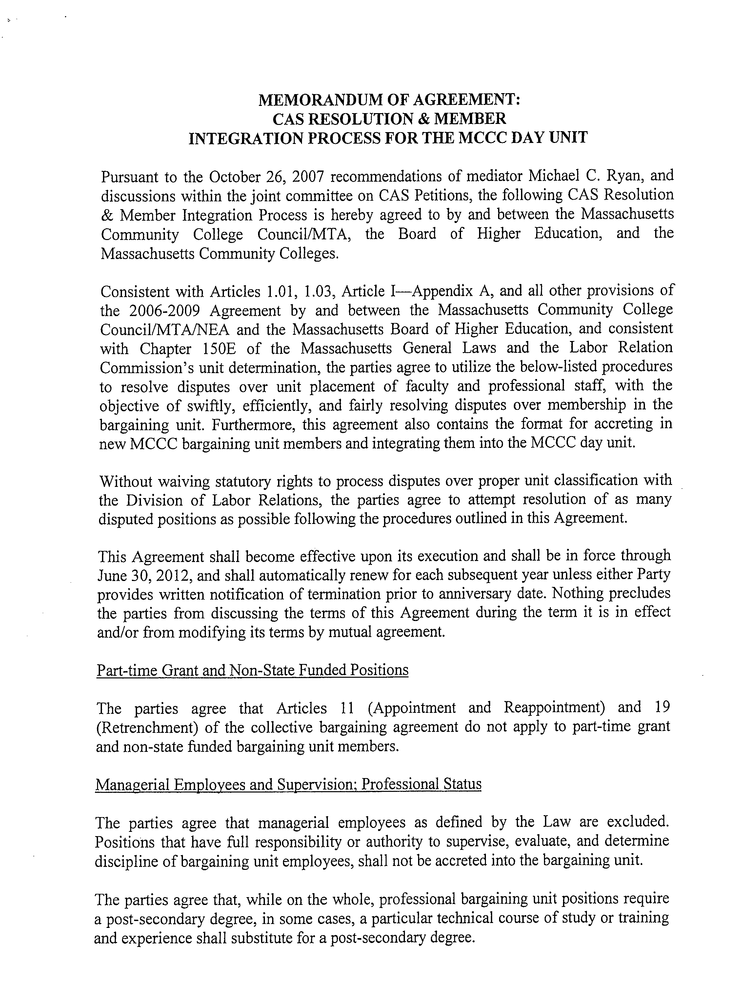

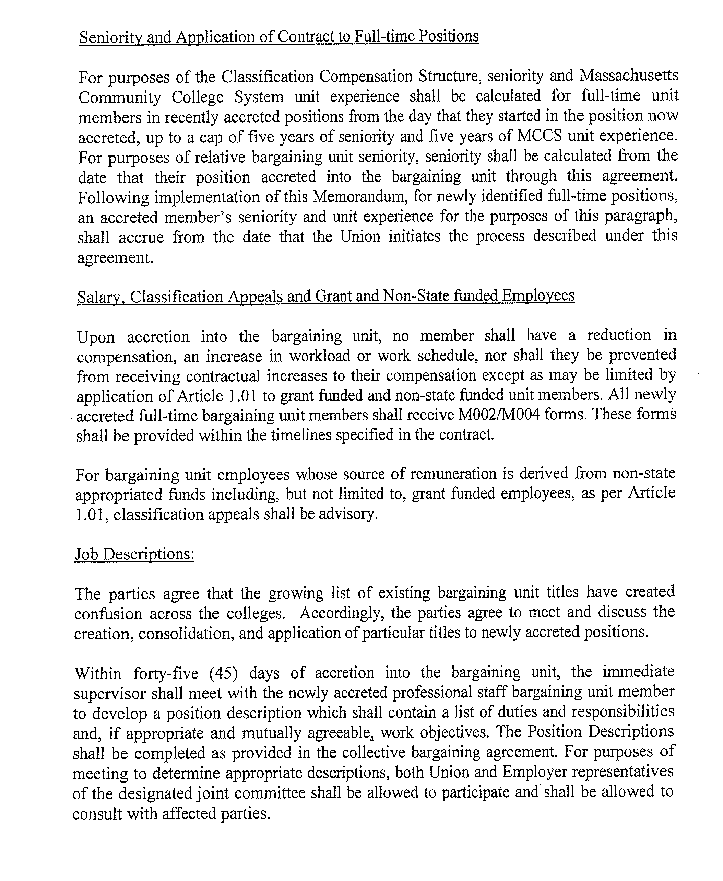

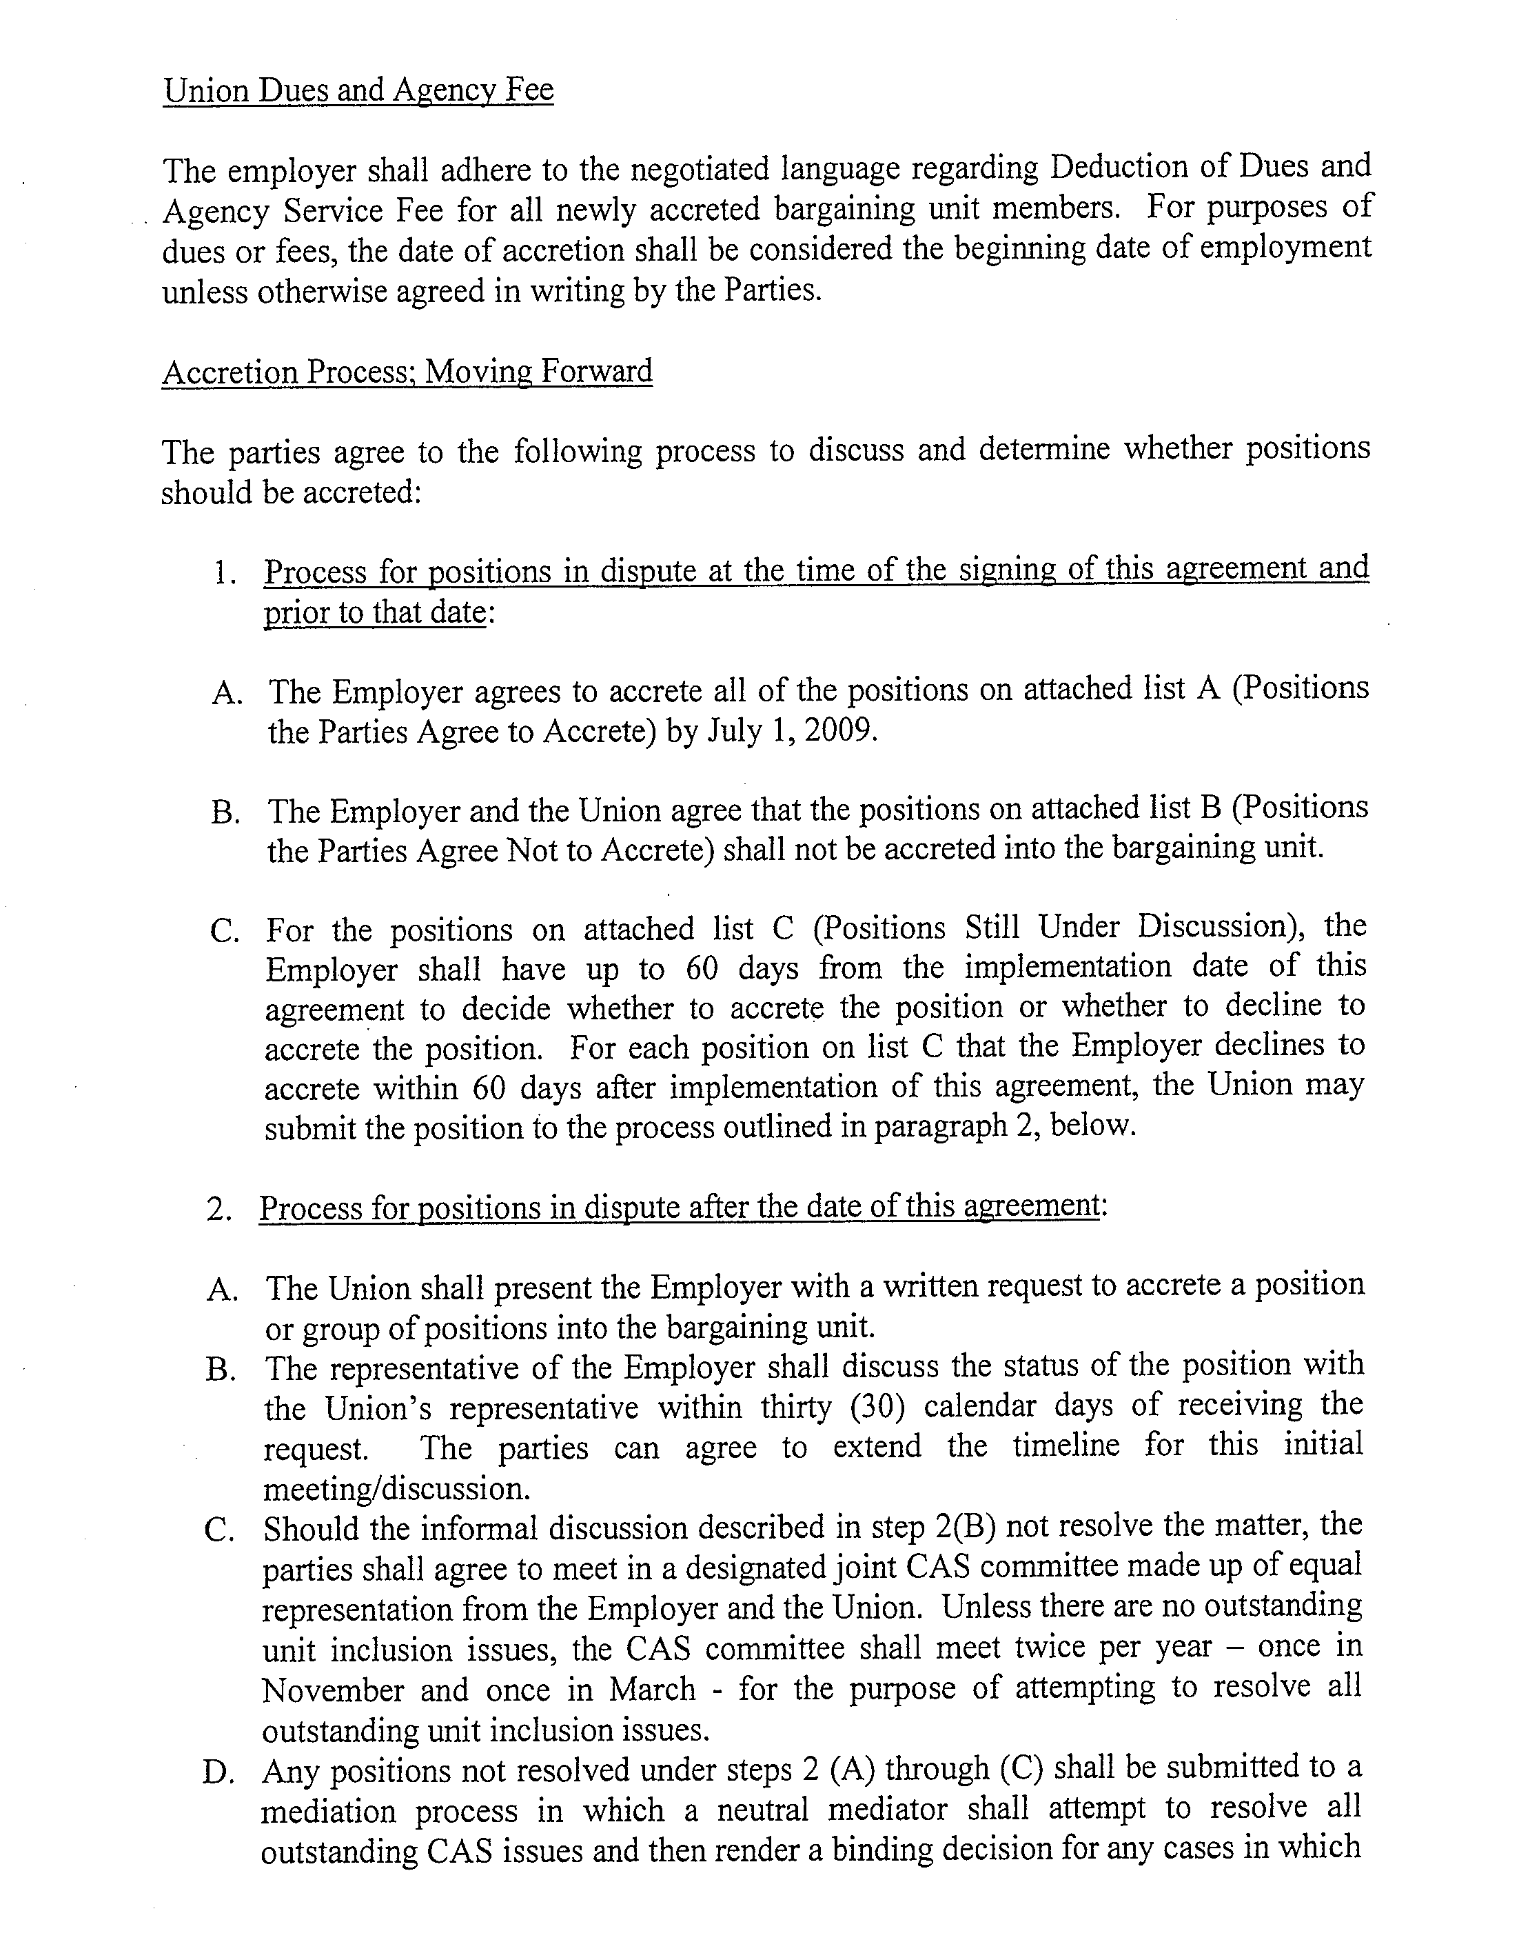

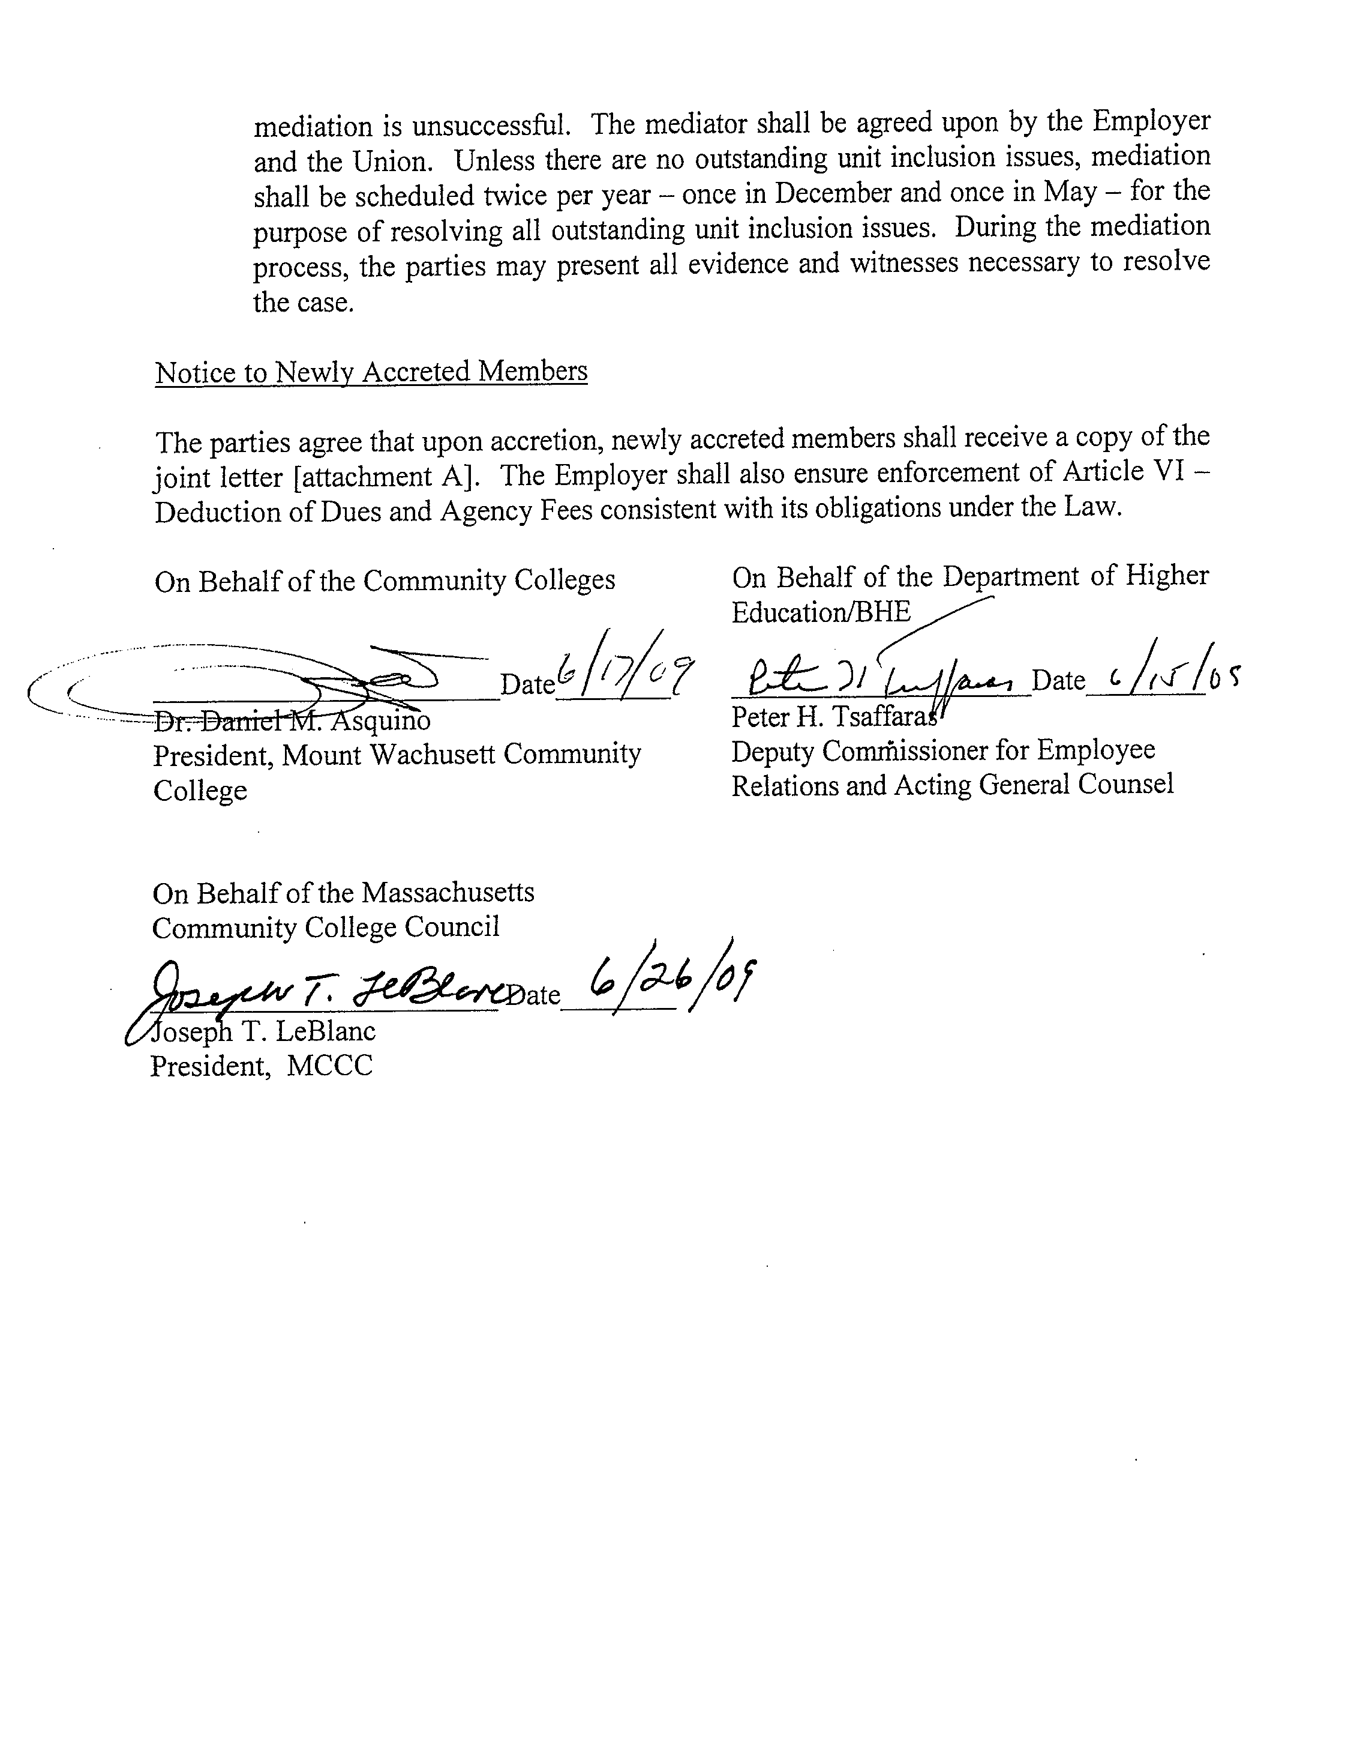

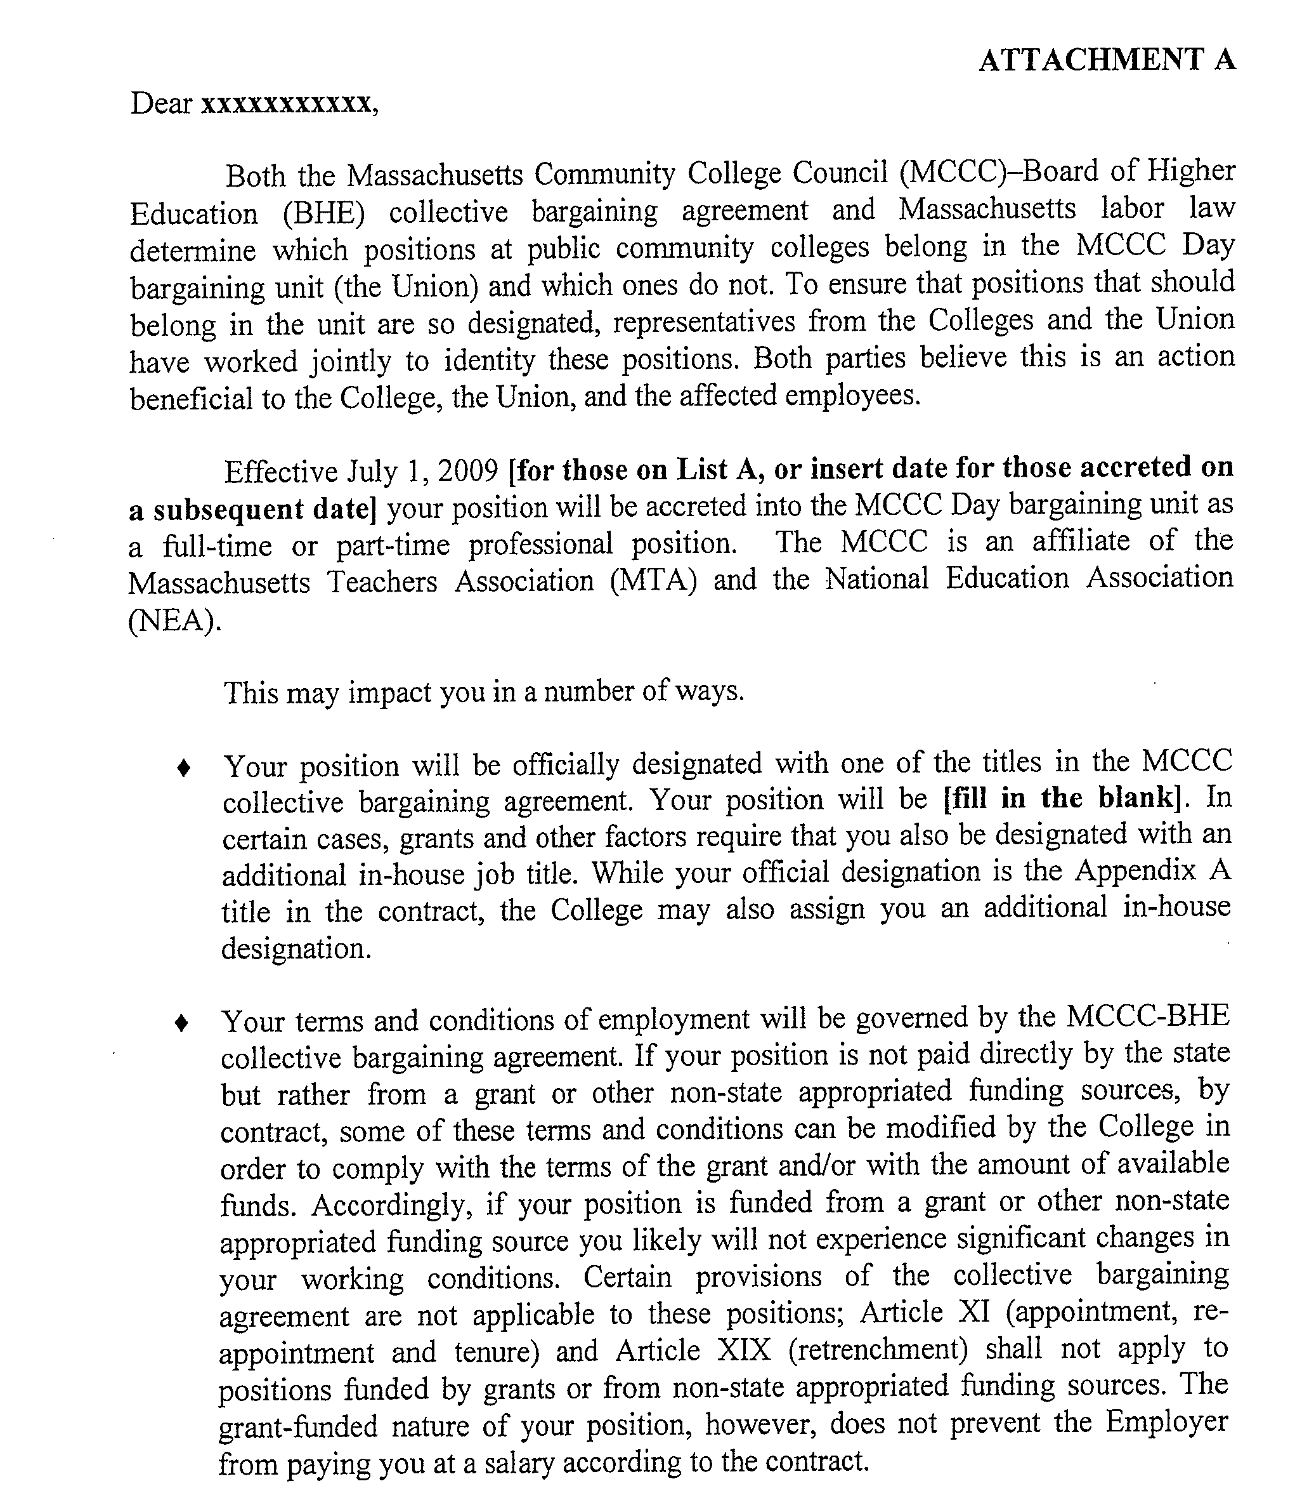

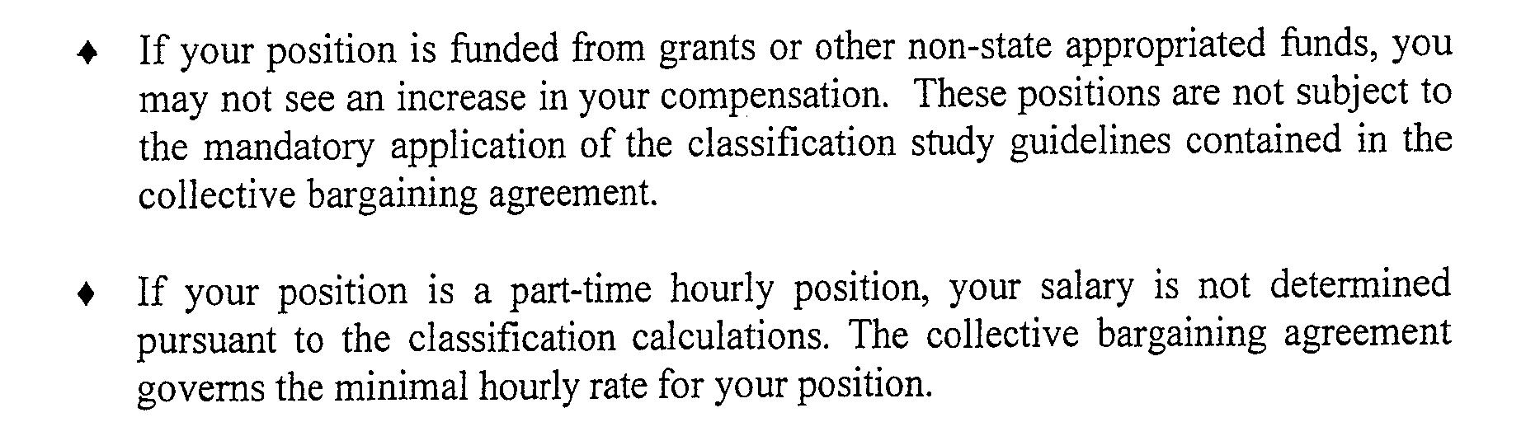

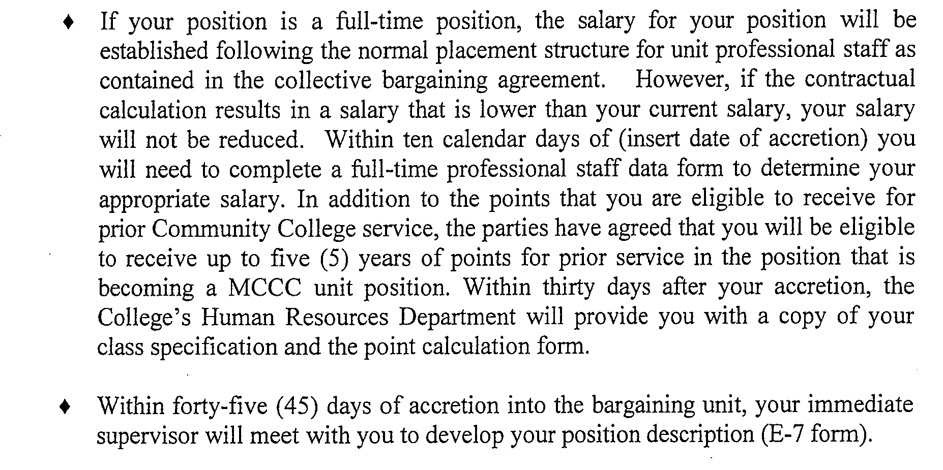

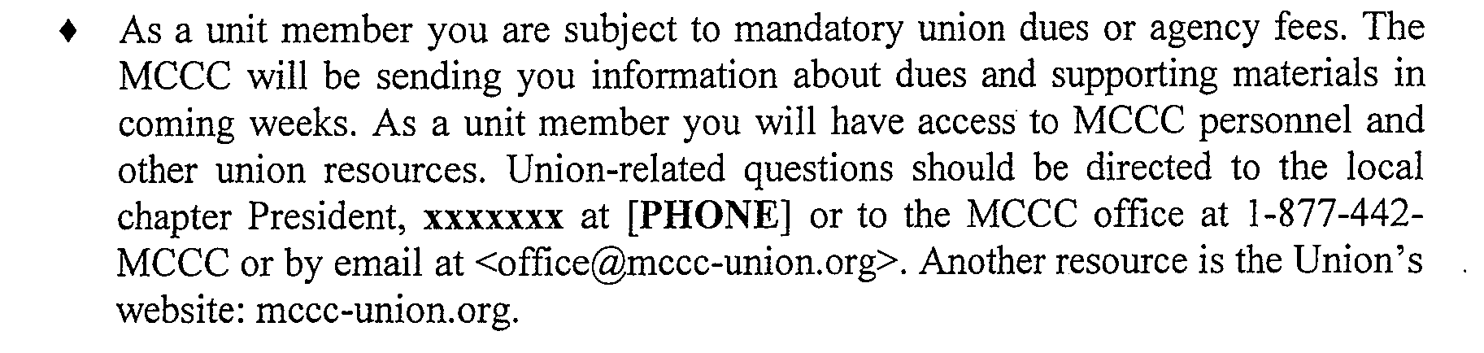

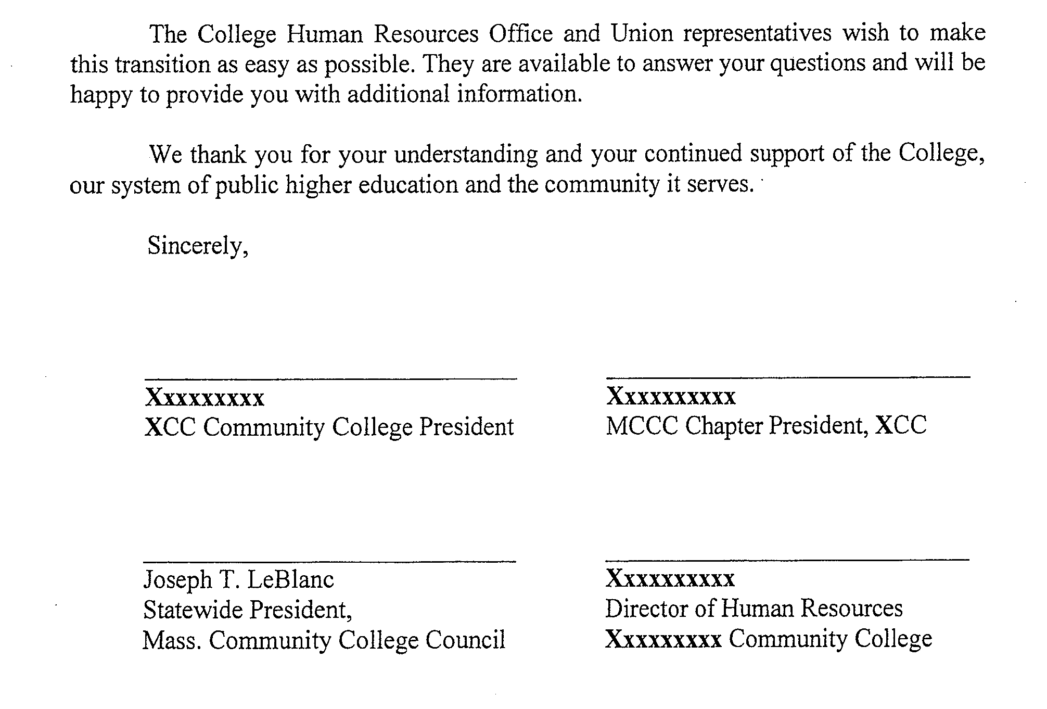

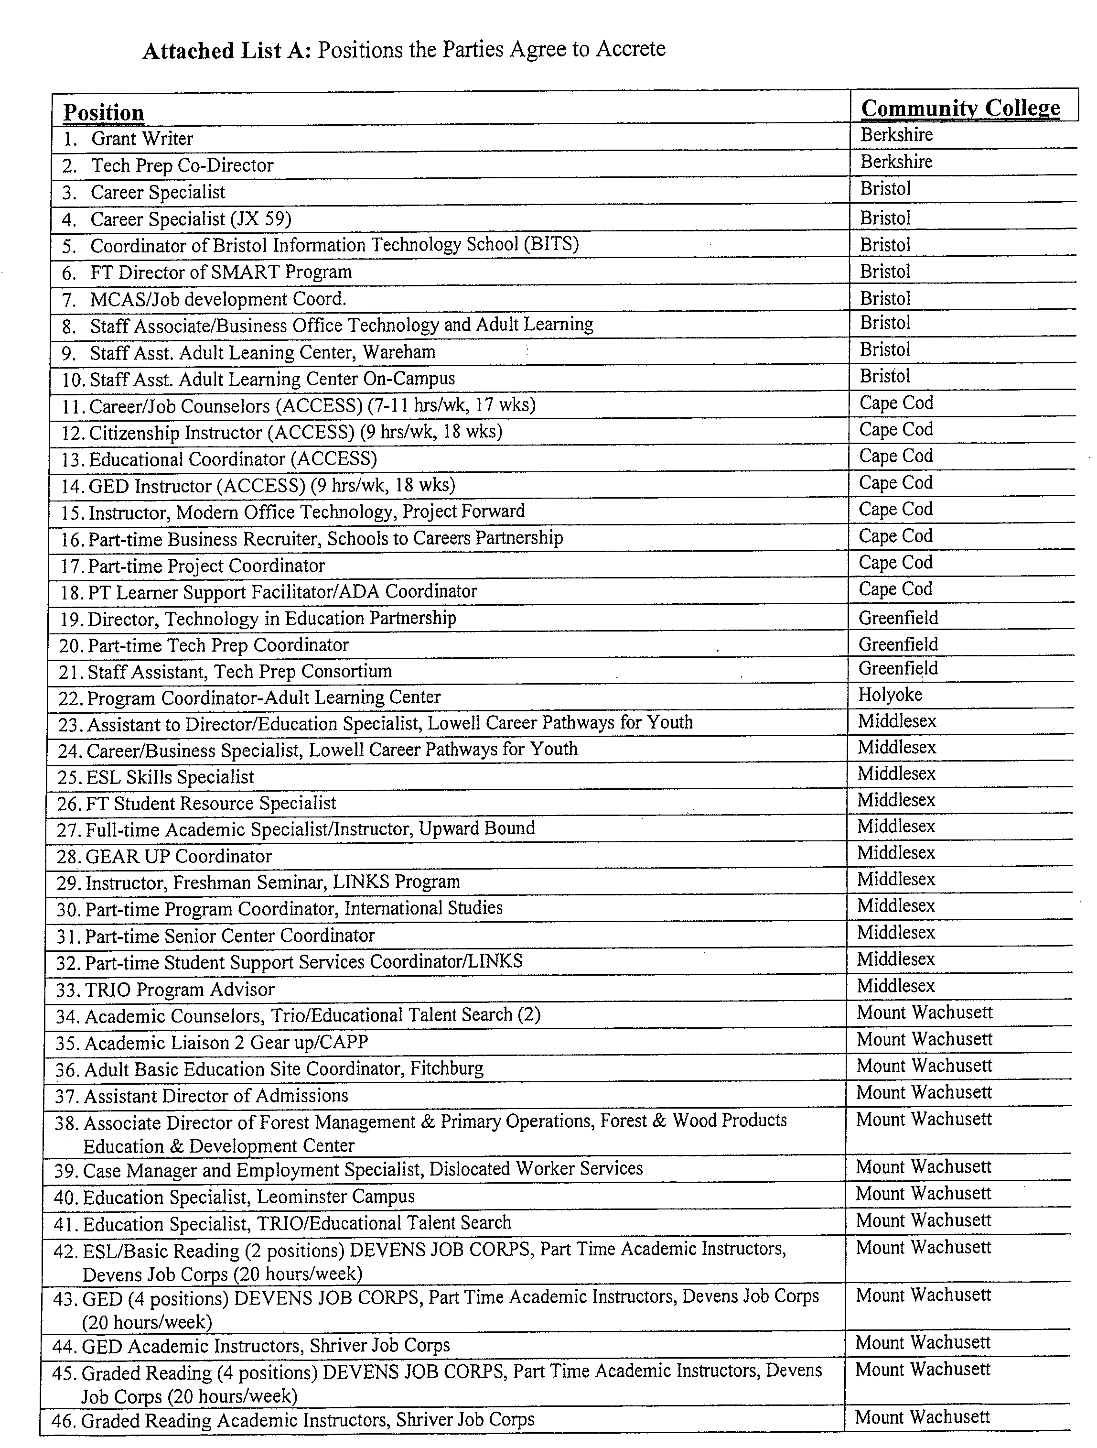

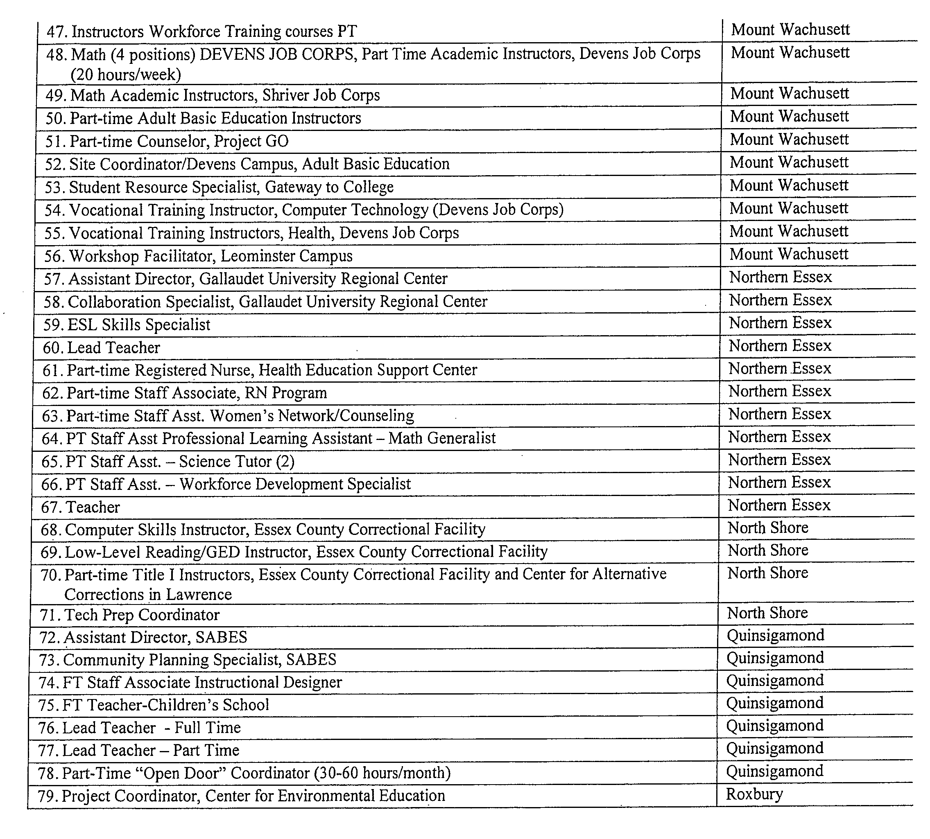

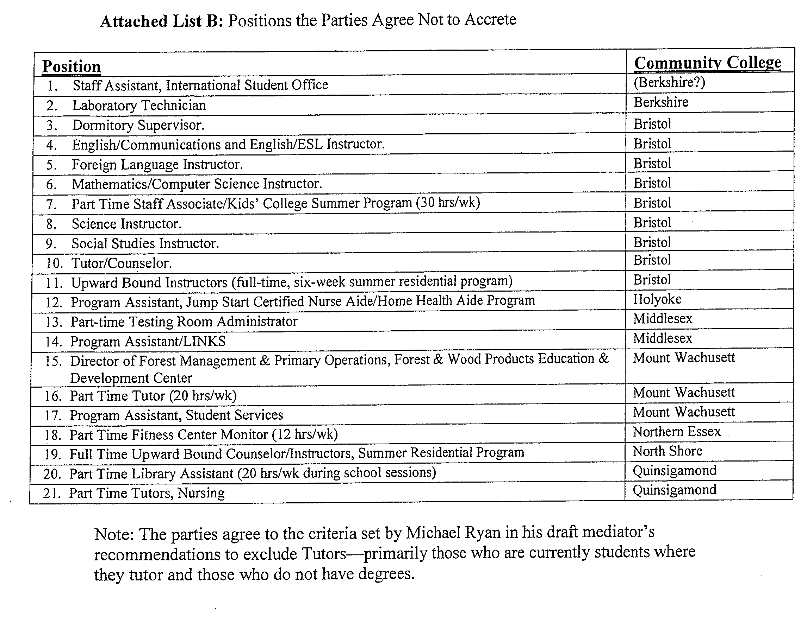

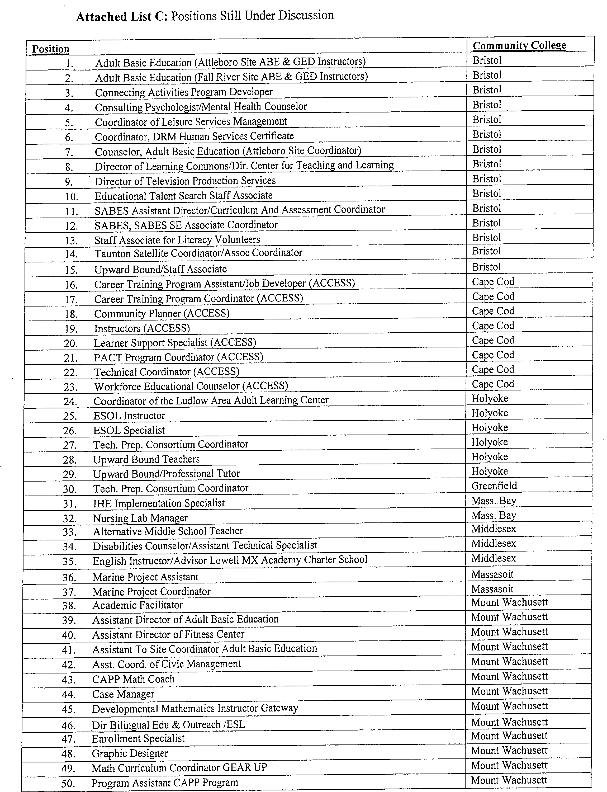

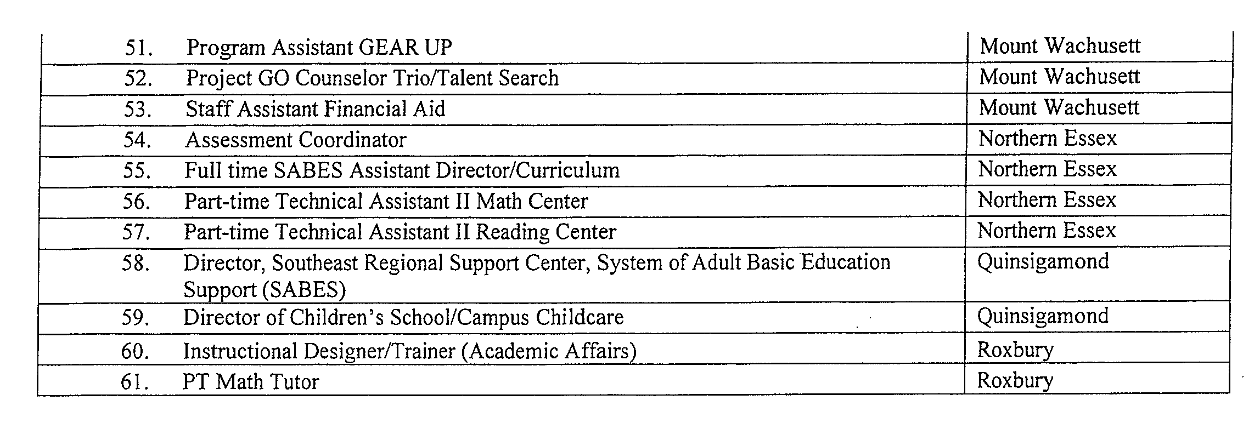

## Written Request to Accrete Position into MCCC Day Unit

To College Human Resources Officer:

College:

Disputed Position(s)/Job Title*:

Statement of Petition:

Requested by**:

Union Representative Title

Signature Date of Request

Please attach job description(s) or posting(s), if available.

The representative of the Employer shall discuss the status of the position with the Union’s representative within thirty (30) calendar days of receiving the request. The parties can agree to extend the timeline for this initial meeting/discussion.

cc: Dennis Fitzgerald, MCCC Day Grievance Coordinator, [Grievance-Day@mccc-union.org](mailto:Grievance-Day@mccc-union.org)

MTA Higher Ed. Consultant for MCCC, Massachusetts Teachers Association, mtaconsultant@mccc-union.org

* Multiple positions with the same title and duties need only one Request to Accrete form. For ease of tracking, use a separate Request to Accrete form for each title.

** Requests to accrete positions may be made only by the MCCC President, MCCC Chapter President, or specified designee.

## College’s Response to Written Request to Accrete Position into MCCC Day Unit

To Union Representative:

Disputed Position(s)/Job Title*:

College:

Parties agreed to extend Step I beyond 30 days?

Date of Request

**Accreted into unit** _____ **Not Accreted** _____ Date:

College Representative Title

cc: Dennis Fitzgerald, MCCC Day Grievance Coordinator, [Grievance-Day@mccc-union.org](mailto:Grievance-Day@mccc-union.org)

MTA Higher Ed. Consultant for MCCC, Massachusetts Teachers Association, mtaconsultant@mccc-union.org

* Multiple positions with the same title and duties need only one Response form. For ease of tracking, use a separate Response form for each title.

** Requests to accrete positions may be made only by the MCCC President, MCCC Chapter President, or specified designee.

## 

## Accretion Appeal to Joint CAS Committee

To: MTA Higher Ed. Consultant for MCCC, mtaconsultant@mccc-union.org

Office of the General Counsel for the Community Colleges, c/o Middlesex Community College, 591 Springs Rd., Bldg 2, Bedford, MA 01730

Disputed Position(s)/Job Title*:

College:

Appealed by**:

Union Representative Date

The Union Representative shall submit this form with a copy of Written Request (Form A), posting/job description, up to one-page written statement, and other supporting documentation.

The College shall have the opportunity to provide the addressees with a one-page statement and supporting documentation prior to the meeting of the addressees to review the position.

All efforts shall be made to submit this appeal and any statements and documentation to the above-listed addressees prior to the first day of the month that the committee next meets. The J.C.C. meets in committee to decide accretion requests two times a year--once in November and once in March. If the material is not received in advance of the meeting, the committee might not have adequate ability to evaluate the position.

cc: Dennis Fitzgerald, MCCC Day Grievance Coordinator, [Grievance-Day@mccc-union.org](mailto:Grievance-Day@mccc-union.org)

Human Resources Officer _________________,

Community College,

* Multiple positions with the same title and duties need only one Appeal form. For ease of tracking, use a separate Appeal form for each title.

** Requests to Appeal positions may be made only by the MCCC President, MCCC Chapter President, or specified designee.

## Decision of Joint CAS Committee

To: Union Representative**

Human Resources Officer , Community College,

Disputed Position(s)/Job Title*:

College:

Date of Appeal to J.C.C:

**------------------------------------------------------------------------------------------------------------**

**DECISION OF J.C.C.:**

**Accreted into unit** **🞏** **Not Accreted** **🞏** Date:

**Not Resolved** **🞏**

On Behalf of College Representatives to the Joint CAS Committee Title

On Behalf of Union Representatives to the Joint CAS Committee Title

A decision not resolved by the Joint CAS Committee shall be submitted to binding mediation with Forms A, B and attachments. Mediation shall be scheduled once in December and once in May.

cc: Dennis Fitzgerald, MCCC Day Grievance Coordinator, [Grievance-Day@mccc-union.org](mailto:Grievance-Day@mccc-union.org)

MTA Higher Ed. Consultant for MCCC, mtaconsultant@mccc-union.org

Office of the General Counsel for the Community Colleges, c/o Middlesex Community College, 591 Springs Road, Building 2, Bedford, MA 01730

# 

# MEMORANDUM OF AGREEMENT NO. 3: INDIVIDUALIZED INSTRUCTION SPECIALISTS

Pursuant to the authority delegated to it by the parties to the 1990‑1993 collective bargaining agreement as part of the settlement of that agreement, the Joint Study Committee has agreed to the following resolution of outstanding issues regarding "Individualized Instruction Specialists":

1. The following positions will be considered to be Individualized Instruction Specialists (IIS) for purposes of this Agreement:

1. five (5) positions of Individualized Instruction Specialist at Middlesex Community College;
2. twelve (12) positions of Learning Center Specialist at Massachusetts Bay Community College;
3. two (2) positions of Self‑directed Learning Specialist at Bunker Hill Community College; and
4. one (1) position of Coordinator of Self‑directed Learning at Bunker Hill Community College.

2. No additional IIS positions will be appointed at any Community College without Labor Counsel for the Community Colleges having first given the President of the MCCC notice and, upon request of the MCCC President, an opportunity for the President of the College, or the President’s designee, to meet and confer with the MCCC President

3. All outstanding charges at the Labor Relations Commission and/or grievance arbitration cases on the issue of IIS shall be withdrawn by the MCCC.

Note: This Memorandum of Agreement was originally executed on January 6, 1994, by George Traicoff and Cynthia S. Denehy, Labor Counsel, for the Employer, and Dennis Fitzgerald for the MCCC.

On July 1, 1999, the title of Individualized Instruction Specialist was changed to the Classification Title of Learning Specialist.

# Appendix A: Principles Statement on Student Learning Outcomes and Assessment

Fundamental to the mission of the Massachusetts’ Community Colleges is a commitment to high quality education and the promotion of student success. One vehicle to promote these objectives is Student Learning Outcomes which may be produced and assessed to plan improvements to courses, programs, and institutional effectiveness.

As the administration and unit members at individual Community Colleges establish Student Learning Outcomes processes to support additional strategies for successful student learning, the parties affirm the following principles as essential to the professional rights and responsibilities of unit members as set forth in the parties’ collective bargaining agreement and the governance structures of each college:

1. Academic Freedom is a long-held principle in higher education and is defined in Article VII Academic Freedom and Responsibility of the parties’ collective bargaining agreement. In acknowledging the core value of academic freedom, and that faculty have the subject matter expertise in their respective fields, the parties affirm that Student Learning Outcomes (SLOs) are faculty-driven and the development, implementation, and assessment of Student Learning Outcomes (SLOs) require the systematic involvement of faculty and appropriate unit professional staff.
2. Unit members are responsible for development of the SLOs, as well as methods, instruments and standards of assessment for instructional courses and programs. Faculty shall have primary authority over any dissemination of the assessment data and results at the course section level. Artifacts related to SLOs will be confidential and disassociated from individual unit members.
3. The administration of each college shall support and fund SLO training, professional development and ongoing work related to SLOs. As circumstances warrant, this may include, but not be limited to, reassigned time, stipends and other related items.
4. The colleges will be cognizant and respectful of the instructional role that part-time day unit faculty and full and part-time professional staff play relative to SLOs. Any work performed by them on SLOs will be performed and compensated per the terms of the collective bargaining agreement.
5. New institutional procedures (those that affect more than one discipline) for the development, implementation, and assessment of SLOs will be established with the involvement of the unit members pursuant to each institution’s governance procedures and with the initial consultation with representatives of the MCCC Chapter. MCCC Chapter representatives shall be included in such procedures when they affect the terms and conditions of unit members’ employment as defined in M.G.L. Chapter 150E.
6. Unit members are currently evaluated pursuant to the processes outlined in Article XIII of the collective bargaining agreement. Student learning outcomes and assessment are not in any way intended to measure the effectiveness of any individual faculty or professional staff member of the college community and will not be used to do so. Unit members will not be evaluated on SLOs, including, but not limited to, the content of SLOs, students’ achievement of SLOs, the results of SLO assessments, or the methods used to assess the SLOs.
7. Unit member rights, as established the by parties’ collective bargaining agreement and applicable laws, will be maintained during the production, implementation and assessment of SLOs.

# Appendix B: Salary Grid(s)

Memorandum of Agreement On

The Salary Grid Compensation System developed by the

BHE and MCCC Joint Labor-Management Salary Grid Committee

May 16, 2017 as amended by the Parties effective first full payroll of July 2022

Whereas, the Board of Higher Education and the Massachusetts Community College Council are committed to providing salaries for unit members that reflect the contributions that unit members make to the community colleges and Massachusetts Higher Education system; and

Whereas, the parties desire a more predictable and understandable salary system for unit members that builds upon the current Classification Study; and

Whereas, the parties agree that certain professional and academic achievements should be recognized in unit member compensation; and

Whereas, the parties, under the current collective bargaining agreement, established a Joint Labor Management Salary Grid Committee to develop and recommend a salary grid compensation system for unit members for implementation by July l, 2017.

Therefore, the parties agree to the following:

1. Effective July 1, 2017, a salary grid system as described below shall be implemented for the MCCC Day Unit faculty and professional staff whose salaries are currently determined by the BHE/MCCC 1999 Classification Study, as amended (herein after “Classification Study") and incorporated into the Collective Bargaining Agreement (CBA). This system shall supersede Article 21.02 effective July l, 2017.
2. Effective July l, 2017, unit members whose wages are not determined by the Classification Study and are paid on an hourly basis under CBA Article 21.01.C.2.b shall have their hourly rate increased by 2.5%.
3. Initial salary calculation for new hires, reclassifications and transfers shall continue to be determined by the Classification Study including competitive factors where determined by the College. Once the salary is calculated, the unit member shall be placed on the appropriate column of their highest education credential at the closest interval which at least equals or is greater than the calculated salary. When a new hire, reclassification or transfer's salary is based on competitive factors as referenced in the Classification Study, the unit member shall be placed on their commensurate education column and interval unless the unit member's salary calculation is greater than the minimum salary of Column H. In those instances, the unit member shall be placed on the appropriate interval in Column H.
4. There shall be separate salary grids for Day Unit faculty' and professional staff. Copies of the salary grids are attached hereto and incorporated herein.
5. Grant-funded faculty and professional staff shall be eligible for placement and advancement under the salary grid system to the extent allowed by the grant's funding levels and/or the grant's other terms and conditions.
6. Effective July l, 2017, the initial year of the salary grid system implementation, each unit member on the payroll as of June 30, 2017 shall be placed:
7. On the appropriate faculty or professional staff grid commensurate with their rank/grade; and,
8. On the column commensurate with their highest education credential and/or credits. For the purposes of implementing the grids, where a current unit member's salary exceeds the maximum salary (Interval l) for the column commensurate with their highest education credential and/or credits, the unit member shall be placed on Column H of the grid.
9. On the interval closest to their June 30, 2017 salary and that guarantees a minimum increase of two percent (2%) rounded to the nearest 1/100th of I percent.
10. Individuals whose salary exceeds the maximum salary (Interval l) on Column H of their respective grid shall retain their current salary and receive an across-the-board increase of 2.0%.
11. Grid Structure: Professional Staff
12. There shall be a separate salary grid for each professional staff grade (Grades 2-7) [See Attachments I - 6];
13. There shall be 30 intervals on each grid that allow for vertical advancement within the grid;
14. There shall be a 1.25 percent increase in-value between each interval'
15. There shall be columns on each grid that value academic credentials or credits. There shall be an increase for the credentials and credits as follows:
16. Column A- Bachelors (contractual minimum)
17. Column B- Masters (contractual minimum)
18. Column C- Masters +1 S (2.5%)
19. Column D- Masters +30/Double Masters/C.A.G.S./MFA/ MSS/ MCMHC (3.0%)
20. Column E- Masters +45 (2.5%)
21. Column F- ABD (3.0%)
22. Column G- PH.D/M.D/JD/Ed.D (5.0%)
23. There shall be an additional column (Column H) on each grid for competitive placement as referenced in the Classification Study.
24. Advancement within the Professional Staff grid system

a. Professional staff shall advance intervals upon the following professional achievements:

1. Upon the 4th year of regular appointment as outlined in Article 11.02.A.2 of the CBA, professional staff unit members shall advance two intervals.
2. Professional staff eligible for advancement on the grid per 8.a.i above shall receive the associated salary adjustment on the July 1 following the notice of the 4th year of reappointment.
3. Professional staff who are tenure-eligible shall advance three intervals upon receipt of tenure. Professional staff who are not tenure-eligible shall advance three intervals upon the 7th year of regular appointment as long as such advancement complies with the requirements of Section of this Memorandum of Agreement and provided their most recent evaluation was "other than unsatisfactory".
4. Professional staff who advance intervals per section 8.a.iii above shall receive the associated salary adjustment effective the July 1 following the award of tenure or the notice of the 7th year of reappointment.
5. Professional staff shall advance two intervals on the July 1 following the 9th anniversary of their hire date provided their most recent evaluation was "other than unsatisfactory".

b. Attainment of New Academic Credentials

1. Upon earning new academic credentials or credits, professional staff unit members will be advanced to the same interval in the column that corresponds to the new credential and/or credits earned.
2. Professional staff eligible for advancement on the grid per 8.b.i above shall receive the associated salary adjustment on either September 1 or January 15 following the attainment and submission of new academic credentials or credits. This language supersedes the point and dollar values for new academic credentials earned after hire as noted on the page entitled "New Hire Tables 2"of the parties' collective bargaining agreement.
3. Successful Completion of Post-tenure Evaluation
4. Upon receipt of an "other-than unsatisfactory" post-tenure evaluation, professional staff shall advance two (2) intervals for up to 10 post-tenure reviews.
5. Professional staff who receive "other than unsatisfactory" post-tenure evaluations shall receive the associated salary adjustment effective the July following the evaluation,
6. If a professional staff unit member is eligible for an interval per Section 8,c.i, but is at Interval I in their respective education column, the unit member shall receive a one-time cash amount, not added to the unit member's salary, that is equal to the unit member's annual base salary multiplied by the interval percentage value on the grid ( l .25%). Said payment shall be made in the first payroll after the July 1 following the post-tenure evaluation.

d. Service Achievements

i. Effective the first payroll period in July 2022, any professional staff member upon achieving certain benchmark years of service within the Community College system based on date of hire, will be advanced an interval as follows:

1. 15 years of Service-One (1) interval

2. 20 years of service-One (1) interval

3. 25 years of service-One (1) interval

4. 30 years of service-One (1) interval

Professional staff eligible for advancement on the grid per 8.d.i above shall receive the associated salary adjustment on July 1 following the attainment of the service achievement.

ii. Initial implementation- Unit members who have already achieved and

surpassed the benchmark years of service shall be awarded all prior service

achievement intervals on the following schedule:

* + - 1. 15 years of service- All unit members with at least 15 years of service will receive 1 intervals effective and retroactive to 7/1/2022.

1. 20 years of service- All unit members with at least 20 years of service will receive an additional 1 interval effective and retroactive to 7/1/2022. This is in addition to prior service achievement intervals already awarded.
2. 25 years of service- All unit members with at least 25 years of service will receive an additional 1 interval effective 1/1/2023. This is in addition to prior service achievement intervals already awarded.
3. 30 years of service- All unit members with at least 30 years of service will receive an additional 1 interval effective 6/30/2023. This is in addition to prior service achievement intervals awarded.
4. Grid Structure: Faculty
   1. There shall be a separate salary grid for each faculty rank: Instructor, Assistant Professor, Associate Professor, Professor (See Attachments 7-10).
   2. There shall be a 2.5% increase in value between each rank.
   3. There shall be 25 intervals on the Instructor and Assistant Professor grids and 35 intervals on the Associate Professor and Professor grids that allow for vertical advancement with in the grid.
   4. There shall be a 1.25% increase in value between each interval.
   5. There shall be columns on each grid that value academic credentials or credits. There shall be an increase for the credentials and credits as follows:
5. Column A- Bachelors (contractual minimum)
6. Column B- Masters (contractual minimum)
7. Column C- Masters +15 (2.5%)
8. Column D- Masters +30/Double Masters/C.A.G.S./MFA/ MSS/ MCMHC (3.0%)
9. Column E- Masters +45 (2.5%)
10. Column F- ABD (3.0%)
11. Column G- PH.D/M.D/JD/Ed.D (5.0%)
    1. There shall also be an additional column (Column H) on each grid for competitive factor placement as referenced in the Classification Study.
12. Advancement within the Faculty grid system
    1. Change of Rank
       1. Upon the following changes of rank, faculty will be advanced to the same column and interval on the corresponding grid for the higher rank. The actual interval number for advancement from Assistant Professor to Associate Professor shall be a different number due to additional intervals added to the Associate Professor Rank. (See the "Prior Rank Interval" column in the Associate Professor grid and Paragraph 9.c of this Agreement.)

1. Instructor to Assistant Professor

2. Assistant Professor to Associate Professor

3. Associate Professor to Professor

ii. Faculty who receive a rank change shall receive the salary adjustment associated with the change of rank in the first payroll of the academic year in which the rank change becomes effective.

* 1. Attainment of New Academic Credentials
     1. Upon earning new academic credentials or credits, faculty unit members will be advanced to the same interval in the column that corresponds to the new credential and/or credits earned.
     2. Faculty eligible for advancement on the grid per 10.b.i above shall receive the associated salary adjustment on either September 1 or January 15 following the attainment and submission of new academic credentials or credits. This language supersedes the point and dollar values for new academic credentials earned after hire as noted on the page entitled "New Hire Tables I "of the parties' collective bargaining agreement.
  2. Receipt of Tenure

1. Upon receipt of tenure, faculty shall advance one interval(s).
2. Faculty who receive tenure shall receive the associated salary adjustment in the first payroll of the academic year in which tenure becomes effective.
   1. Successful Completion of Post-Tenure Evaluation
      1. Upon receipt of an "other than unsatisfactory" post-tenure evaluation, faculty shall advance two (2) intervals for up to 10 post-tenure evaluations.
      2. Faculty who receive "other than unsatisfactory" post-tenure evaluation shall receive the associated salary adjustment in the first payroll of the academic year following the successful completion of the post-tenure evaluation.
      3. If a faculty unit member is eligible for an interval per Section 10.d.i, but is at Interval I in their respective education column, the unit member shall receive a one-time cash amount, not added to the unit member's salary, which is equal to the unit member's annual base salary multiplied by the interval percentage value on the grid (l .25%). Said payment shall be made in the first payroll of the academic year following the post-tenure evaluation.

e. Service Achievements

i. Effective the first payroll period of July 2022, faculty members upon achieving certain benchmark years of service within the Community College system based on dates of hire will be advanced an interval as follows:

1. 15 years of Service-One (1) interval

2. 20 years of service-One (1) interval

3. 25 years of service-One (1) interval

4. 30 years of service-One (1) interval

Faculty eligible for advancement on the grid per 10.e.i above shall receive the associated salary adjustment on first payroll of the academic year following the attainment of the service achievement.

ii. Initial implementation- Unit members who have already achieved and surpassed the benchmark years of service shall be awarded all prior service achievement intervals on the following schedule:

* 1. 15 years of service- All unit members with at least 15 years of service will receive 1 interval effective and retroactive to 7/1/2022.
  2. 20 years of service- All unit members with at least 20 years of service will receive an additional 1 interval effective and retroactive to 7/1/2022. This is in addition to prior service achievement intervals awarded.

c. 25 years of service- All unit members with at least 25 years of service will receive an additional 1 interval effective 1/1/2023. This is in addition to prior service achievement intervals awarded.

d. 30 years of service- All unit members with at least 30 years of service will receive an additional 1 interval effective 6/30/2023. This is in addition to prior service achievement intervals awarded.

1. The parties agree to meet regarding the initial placement of unit members on the grid(s) or on any other issues that may arise related to implementation of the salary grid system.
2. The terms of this agreement do not waive any party's rights under Article X of the CBA.
3. The Collective Bargaining Agreement between the Massachusetts Board of Higher Education (BHE) and the Massachusetts Community College Council (MCCC) dated July I, 2015 to June 30, 2018 shall remain in full force and effect except as modified by the terms of this Memorandum of Agreement.
4. The terms of this Memorandum of Agreement shall not become effective until this Agreement is approved and/or ratified by the parties in accordance with Paragraph B 2 of Appendix B of the parties' collective bargaining agreement. In the event either or both parties fail to approve or ratify this Memorandum of Agreement, this Agreement shall be null and void and of no force-and-effect.

**For the Board of Higher Education:**

/S/ Michael J. Murray_

Date: 2/6/23

**For The Massachusetts Community College Council Day Unit**

**/S/Lisa C. Coole**

Date: 2/6/23

**Memorandum of Agreement**

**On the**

**Change in Intervals in Salary Grid Compensation System for**

**Full Time Unit Employees**

**February 6, 2023**

Whereas, the Board of Higher Education (BHE) and the Massachusetts Community College

Council (MCCC) are committed to providing salaries for full-time faculty and professional staff

that are appropriately reflective of the contributions that unit members provide to the Community

Colleges and Higher Education system in the Commonwealth; and

Whereas, the parties believe that a predictable, user friendly and transparent salary system is an

equitable and efficient way to compensate unit members; and

Whereas, the parties agree that long term college service employees should be recognized in the

employees’ compensation; and

Whereas, the Whereas, the BHE and Union are parties to a Tentative Agreement dated February

6, 2023 (Tentative Agreement) for a successor collective bargaining agreement covering the

period July 1, 2021 to June 30, 2023 (Agreement); and

NOW THEREFORE, the parties agree to amend the existing full-time Day Unit Faculty and

Professional Staff Salary Grids to compensate Community College full-time employees under

the Day Unit collective bargaining agreement, effective in part the first full pay period of July

2022.

The parties agree to revise and readjust the Day Unit Salary Grid MOA and adjust the New

Hire Tables and Full-time Salary Grids to reflect the following:

A. Effective the first payroll in July 2022, the parties agree to realign the minimums

and maximum salaries of the grids by removing the three (3) lowest intervals on

each Salary Grid at the minimum and adding three (3) new intervals at the

maximum end of each grid as follows:

1. Instructor Grid -remove current intervals 25, 24, and 23. The current Interval

22 becomes the minimum and is renumbered. Add three (3) new intervals

after the current Interval 1. Renumber intervals as appropriate.

2. Assistant Professor- remove current intervals 25, 24 and 23 The current

Interval 22 becomes the minimum and is renumbered. Add three (3) new

intervals after the current Interval 1. Renumber intervals as appropriate.

3. Associate Professor-remove current intervals 35, 34 and 33. The current

Interval 32 becomes the minimum and is renumbered. Add three (3) new

intervals after the current Interval 1. Renumber intervals as appropriate.

4. Professor-remove current intervals 35, 34 and 33. The current Interval 32

becomes the minimum and is renumbered. Add three (3) new intervals after

the current Interval 1. Renumber intervals as appropriate.

5. Professional staff Grades 2-7- remove current intervals 30, 29 and 28. The

current Interval 27 becomes the minimum and is renumbered. Add three (3) new

intervals after the current Interval 1. Renumber intervals as appropriate.

B. The parties agree to move unit members currently on Instructor and Asst.

Professor intervals 25, 24 and 23 or Associate Professor and Professor intervals

35, 34 and 33 or Professional Staff intervals 30, 29 and 28 respectively to the new

minimum salary for their respective education column or Column H, depending

on their current placement.

C. New Hire Tables

The parties agree to adjust the New Hire table minimum salaries to reflect the

minimum Bachelor’s and Master’s salaries on the grids and amend New Hire

Tables 1 and 2 as appropriate.

D. Effective upon ratification and/or approval of the recommendations of the Joint

Labor Management Committee on Distance Education by the aforementioned

parties, the parties agree to revise and readjust the Day Unit Salary Grid MOA,

New Hire Tables and existing Salary Grids by removing the two (2) lowest

intervals on each Salary Grid at the minimum and adding two (2) new intervals at

the maximum end of each grid as follows:

1. Instructor Grid -remove the then current intervals 25, and 24. The then current

Interval 23 becomes the minimum and is renumbered. Add two (2) new intervals

after the then current Interval 1. Renumber intervals as appropriate.

2. Assistant Professor- remove current intervals 25, and 24. The then current

Interval 23 becomes the minimum and is renumbered. Add two (2) new intervals

after the then current Interval 1. Renumber intervals as appropriate.

3. Associate Professor-remove current intervals 35 and 34. The then current

Interval 33 becomes the minimum and is renumbered. Add two (2) new intervals

after the then current Interval 1. Renumber intervals as appropriate.

4. Professor-remove current intervals 35 and 34. The then current Interval 33

becomes the minimum and is renumbered. Add two (2) new intervals after the

then current Interval 1. Renumber intervals as appropriate.

5. Professional staff Grades 2-7- remove current intervals 30, and 29. The then

current Interval 28 becomes the minimum and is renumbered. Add two (2) new

intervals after the then current Interval 1. Renumber intervals as appropriate.

E. Move unit members then currently on Instructor and Asst. Professor intervals 25-

24 or Associate Professor and Professor intervals 35-34 or Professional Staff

intervals 30-29 respectively to the new minimum salary for their respective education

column or Column H, depending on their then current placement.

F. New Hire Tables

In light of the above, the parties agree to adjust the New Hire table minimum

salaries to reflect the minimum Bachelor’s and Master’s salaries on the grids and

amend New Hire Tables 1 and 2 as appropriate.

G. Miscellaneous Provisions

1. The parties agree to meet, if needed to discuss the placement of unit members on the

grid(s) per this Agreement or on any other issues that may arise related to the

implementation of this Agreement.

2. The Collective Bargaining Agreement of the parties as well as the parties’ Day Unit

Full Time Salary Grid MOA shall remain in full force and effect except as modified by

the terms of this agreement.

3. The terms of this Memorandum of Agreement shall not become effective until this

Agreement is approved and/or ratified by the parties’ principals or members as

appropriate in conjunction with the parties’’ successor collective bargaining agreement

for the period July 1, 2021 to June 30, 2023 (2021-2023 CBA). In the event that either or

both parties fail to approve or ratify this Memorandum of Agreement and/or the 2021-

2023 CBA, this Agreement shall be null and void and of no force and effect.

**For the Board of Higher Education:**

/S/ **Michael J. Murray**

Date: 2/6/23

**For The Massachusetts Community College Council:**

/S/ Lisa C. Coole

Date: 2/6/23

**Salary Grids – Faculty – July 2023**



**Salary Grids – Faculty – July 2023**

**Salary Grids – Faculty – July 2023**

**Salary Grids – Faculty – July 2023**

**Salary Grids – Professional Staff – July 2023**



**Salary Grids – Professional Staff – July 2023**

**Salary Grids – Professional Staff – July 2023**

**Salary Grids – Professional Staff – July 2023**

**Salary Grids – Professional Staff – July 2023**

**Salary Grids – Professional Staff – July 2023**

**Salary Grids – Faculty – July 2024**



**Salary Grids – Faculty – July 2024**

**Salary Grids – Faculty – July 2024**

**Salary Grids – Faculty – July 2024**

**Salary Grids – Professional Staff – July 2024**

**Salary Grids – Professional Staff – July 2024**

**Salary Grids – Professional Staff – July 2024**

**Salary Grids – Professional Staff – July 2024**

**Salary Grids – Professional Staff – July 2024**

**Salary Grids – Professional Staff – July 2024**

**Salary Grids – Faculty – January 2025**



**Salary Grids – Faculty – January 2025**

**Salary Grids – Faculty – January 2025**

**Salary Grids – Faculty – January 2025**

**Salary Grids – Professional Staff – January 2025**

**Salary Grids – Professional Staff – January 2025**

**Salary Grids – Professional Staff – January 2025**

**Salary Grids – Professional Staff – January 2025**

**Salary Grids – Professional Staff – January 2025**



**Salary Grids – Professional Staff – January 2025**

# APPENDIX B1: Memorandum of Agreement – Part-Time Salary Grid

**On the**

**Salary Grid Compensation System for Part-Time Unit Employees**

**February 2, 2023 As Amended January 30, 2024**

Whereas, the Board of Higher Education (BHE) and the Massachusetts Community College

Council (MCCC) are committed to providing salaries for part-time faculty and professional staff

that are appropriately reflective of the contributions that unit members provide to the Community

Colleges and Higher Education system in the Commonwealth; and

Whereas, the parties believe that a predictable, user friendly and transparent salary system is an

equitable and efficient way to compensate unit members; and

Whereas, the parties agree that long term college service employees should be recognized in the

employees’ compensation; and

Whereas, the BHE and Union are parties to a Tentative Agreement dated February 6, 2023

(Tentative Agreement) for a successor collective bargaining agreement covering the period July

1, 2021 to June 30, 2023 (Agreement); and

NOW THEREFORE, the parties agree to the following salary grid(s) system to compensate

Community College part-time employees under the Day Unit collective bargaining agreement,

effective the first full pay period of July 2022.

**A. Grid Structure**

1. The parties agree that effective the first full payroll period after July 1, 2022, a salary grid

system described below for MCCC Day Unit part time employees shall be implemented.

Effective the first full pay period after July 1, 2022, each part time unit member on the payroll

shall be placed on the part-time employee salary grid commensurate with their years of

continuous service.

2. Under the salary grid, there shall be four (4) intervals. Each interval shall have a specified

minimum hourly rate. Colleges, in their discretion, may compensate a part time employee at an

hourly rate higher than the specified interval minimum hourly rate. The salary grid(s) is attached

hereto.

3. Nothing in this Memorandum of Agreement shall be construed as reducing the hourly rates of

employees that are currently paid above the minimums outlined in the part-time grid.

**B. Advancement within the Grid**

1. Part-Time employees shall advance intervals on the grid upon the attainment of a specified

number of years of continuous service to the college as of July 1 of each year. In order to receive

credit for the initial year of hire, part-time employees must have at least six (6) months of

continuous service at the college. For the purposes of this Memorandum of Agreement,

continuous service shall mean that the part time unit member has not retired, resigned, or

otherwise separated from employment with the college or had a break of one year or more during

which the part time unit member did not work for the college without authorized leave.

2. Part-time employees shall advance from Interval 1 to Interval 2 upon the commencement of

their fourth (4th) year of continuous service to the college.

3. Part-time employees shall advance from Interval 2 to Interval 3 upon the commencement of

their seventh (7th) year of continuous service to the college.

4. Part-time employees shall advance from Interval 3 to Interval 4 upon the commencement of

their tenth (10th) year of continuous service to the college.

5. A new part-time employee would normally be employed at Interval 1 but may, at the

discretion of the President or the President’s designee, be placed at Interval 2, Interval 3, or

Interval 4 or a higher hourly rate based upon degrees, experience, qualifications, or job market

conditions.

6. Grant funded part-time employees shall be eligible for placement and advancement on the

salary grid to the extent allowed by the grant’s funding levels and/or the grant’s other terms and

conditions.

**C. Miscellaneous Provisions**

1. The parties agree to meet, if needed, to discuss the initial placement of unit members on the

grid(s) or on any other issues that may arise related to the implementation of the grid.

2. The terms of this Memorandum of Agreement do not waive any party’s rights under Article X

of the Collective Bargaining Agreement.

3. The Collective Bargaining Agreement of the parties shall remain in full force and effect except

as modified by the terms of this agreement.

4. The terms of this Memorandum of Agreement shall not become effective until this Agreement

is approved and/or ratified by the parties’ principals or members as appropriate in conjunction

with the parties’ successor collective bargaining agreement for the period July 1, 2021 to June

30, 2023 (2021-2023 CBA). In the event that either or both parties fail to approve or ratify this

Memorandum of Agreement and/or the 2021-2023 CBA, this Agreement shall be null and void

and of no force and effect.

**PART TIME EMPLOYEE SALARY GRID- Minimum Hourly Rates**

**Effective the first full payroll of July 2022**

**Interval 1 (minimum) $32.00**

**Interval 2 at 4th Year of Continuous Service: $35.50**

**Interval 3 at 7th Year of Continuous Service: $39.00**

**Interval 4 at 10th Year of Continuous Service: $42.00**

**Effective the first full payroll in July 2023**

**Interval 1 (minimum) $32.64**

**Interval 2 at 4th Year of Continuous Service: $36.21**

**Interval 3 at 7th Year of Continuous Service: $39.78**

**Interval 4 at 10th Year of Continuous Service: $42.84**

**Effective the first full payroll in July 2024**

**Interval 1 (minimum) $33.95**

**Interval 2 at 4th Year of Continuous Service: $37.66**

**Interval 3 at 7th Year of Continuous Service: $41.37**

**Interval 4 at 10th Year of Continuous Service: $44.55**

**Effective the first full payroll in January 2025**

**Interval 1 (minimum) $35.31**

**Interval 2 at 4th Year of Continuous Service: $39.17**

**Interval 3 at 7th Year of Continuous Service: $43.02**

**Interval 4 at 10th Year of Continuous Service: $46.33**

# Appendix C: Prior Learning Assessment Student Portfolio Evaluations

In regards to Prior Learning Assessment Student Portfolio Evaluations (a student written submission of artifacts and narrative demonstrating their mastery of specific college level competencies), a faculty member may review student portfolios for prior learning assessment pursuant to college procedures in order to determine course equivalences of demonstrated student learner course competencies and outcomes. A faculty member will be compensated at a rate of $150 per portfolio review.

# Memoranda of Agreement – 2021 – 2023 Department Chairs/Curriculum Coordinator/Program Coordinators - 20.11 Compensation

The parties agree that in addition to the workload reduction specified in 20.10, a unit member who

performs the duties and responsibilities of a department chair or curriculum coordinator/work

area/program coordinator/college wide coordinator may receive either an additional workload

reduction or be compensated at a rate of $1,200.00 per credit effective upon the first full pay period

after ratification of the parties’ Agreement or may receive a combination of both an additional

workload reduction and compensation for reason including, but not limited to, accreditation,

program review, size of the department or work area, or other duties as assigned. Any unit member

who agrees to perform the duties and responsibilities of a department chair or curriculum

coordinator/work area/program coordinator/college-wide coordinator as contained in this Article

shall be compensated at the hourly rate of a minimum of $50.00 effective upon the first full pay

period after the ratification of the parties’ Agreement, if the unit member agrees to perform such

duties between Commencement and the first day of Fall classes, during Winter intersession, and

during Spring vacation; provided, however, that such compensation shall not be paid for duties

performed on assigned professional days as provided in Article 12.03.D.6. It is expressly

understood that the President of the College or the President’s designee shall inform the department

chair or curriculum coordinator/work area/program coordinator/collegewide coordinator in a timely

fashion should the employer desire to secure the services of the aforementioned unit member

consistent with this Article.

**For the Board of Higher Education:**

/S/ **Michael J. Murray**

Date: 2/6/23

**For The Massachusetts Community College Council:**

/S/ Lisa C. Coole

Date: 2/6/23

# APPENDIX D: CRITICAL THINKING INTENSIVE COURSES

**Definition:** Critical thinking is the process of purposeful, self-directed judgment. This process improves the quality of thinking and decision-making through reasoned, systematic consideration of context, concepts, methods and evidence.

**Criteria:** A critical thinking course will have (A) components of formally-stated assessments and strategies specifically designed to promote at least two (2) of the following objectives and (B) a process by which the course's critical thinking components will be assessed by the instructor and factored into the students course grade.

**Objectives:**

(The following are process objectives, which reflect thinking processes, as distinguished from content objectives.)

At the completion of the course students will be better able to:

• Evaluate and interpret the meaning of the textual material.

• Support a thesis with evidence appropriate to position and audience.

• Organize and connect ideas.

• View situations from different perspectives.

• Compare and contrast source material so that analysis can be made and theories can be proved or disproved. • Draw inferences, suppositions, and conclusions from source materials.

• Perform a medley of solutions to a possible problem and present those solutions in a logical, coherent manner.

• Differentiate between fact and fiction, concrete and abstract, theory and practice.

• Make estimates and approximations and judge the reasonableness of the result.

• Apply quantitative and/or qualitative techniques, tools, formulas and theories in the solution of real-life problems and recognize when to apply those techniques, tools, formulas, and theories.

• Interpret data presented in tabular and graphical form and utilize that data to draw conclusions.

• Use quantitative relationships to describe results obtained by observation and experimentation.

• Interpret in non-quantitative language relationships presented in quantitative form.

• Apply the scientific method including methods of validating the results of scientific inquiry

December, 2001

# Appendix E: Memorandum of Agreement on the Joint-Labor Management Committee on Distance Education

Whereas, the Board of Higher Education (BHE) and the Massachusetts Community College

Council (MCCC) Day Unit and the MCCC Division of Continuing Education Unit (DCE) are

committed to enriching and increasing the availability of Distance Education at the Community

Colleges and supporting the exploration of high quality pedagogically sound distance education

opportunities to faculty and students; and

Whereas, the parties wish to address the ways in which distance education formulation, training

and delivery impact the Day Unit, the DCE Unit and the Colleges;

Whereas, the BHE and MCCC Day Unit are parties to a Tentative Agreement dated February 6,

2023 (Tentative Agreement) for a successor collective bargaining agreement covering the period

July 1, 2021 to June 30, 2023 (Agreement); and

NOW THEREFORE, the parties agree as follows:

**A. Joint Labor-Management Committee on Distance Education/Online Education**

1. Per the Board of Higher Education March 1, 2018 notice to the MCCC of its intent to re-

open negotiations on the terms of the Distance Education Agreement, the parties agree to

begin negotiations on new or amended provisions regarding Distance Education/Online

Education to be incorporated into the parties’ collective bargaining agreement(s). To that end,

the parties agree that a Joint Labor Management Committee on Distance Education/Online

Education shall be formed. The Joint Committee shall be comprised of representatives of the

BHE/Colleges, the MCCC Day Unit and the MCCC DCE Unit. The Joint Committee shall

meet to bargain new or amended provisions regarding Online (Distance) Education for

incorporation into the BHE and MCCC Day Unit’s successor collective bargaining agreement

effective July 1, 2023 and the BHE MCCC DCE Unit’s successor collective bargaining

agreement effective September 1, 2023. The Joint Committee will commence work no later

than March 1, 2023.

2. The Joint Committee shall be comprised of twelve (12) members, six (6) of which shall be

appointed by the MCCC Day and DCE units, of which no more than two (2) unit members

shall be from any one College and six (6) members shall be appointed by the BHE/Colleges.

The Employer shall provide the six (6) MCCC representatives serving on the Joint Committee

with a stipend as follows: Spring semester 2023 $1,500.00; Summer 2023 $1,500.00 and Fall

semester, if needed, one (1) three credit course reassigned time or a $3,000.000 stipend.

**B. The Joint Committee’s Charge**

The Joint Committee shall make joint recommendations to the MCCC units and the BHE

regarding the inclusion of Distance Education provisions into the successor Day Unit and

DCE Unit collective bargaining agreements. Should the Day and DCE Units and the

BHE/Colleges approve the recommendations reached by the Joint Committee, including any

proposed changes to the collective bargaining agreements, they shall be incorporated into the

successor collective bargaining agreements of the MCCC Day Unit and MCCC DCE Unit.

**C. Time to Complete the Joint Committee’s Work**

The parties agree to prioritize the work of the Joint Committee and shall use best efforts to reach

a joint recommendation to the parties on or before December 31, 2023.

**D. Effective Date of this Agreement**

The terms of this Memorandum of Agreement shall not become effective until this

Agreement is approved and/or ratified by the parties’ principals or members as appropriate in

conjunction with the parties successor collective bargaining agreement for the period July 1,

2021 to June 30, 2023 (2021-2023 CBA). In the event that either or both parties fail to approve

or ratify this Memorandum of Agreement and/or the 2021-2023 CBA, this Agreement shall be

null and void and of no force and effect.

**For the Board of Higher Education:**

/S/ Michael J. Murray_

Date: 2/6/23

**For The Massachusetts Community College Council Day Unit**

**/S/Lisa C. Coole**

Date: 2/6/23

**For The Massachusetts Community College Council DCE Unit**

DeAnna Putnam (e-signature)

Date: 2/7/23