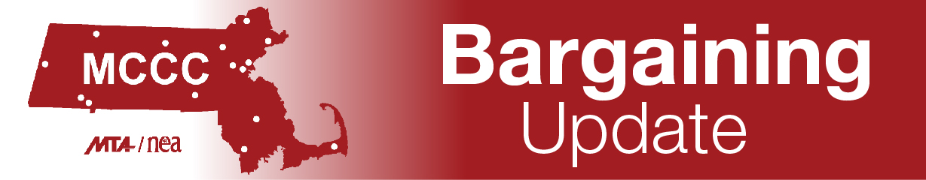
As of-7-28-21
Hello MCCC Day Unit Members:
We hope you are enjoying the summer and thank you for taking the time to read these updates. On June 28 the Day Negotiations team had our first meeting with management. We met management’s team which includes the following:
Michael Murray, Director of Employee and Labor Relations, MA Department of Higher Education
Carol Wolff-Fallon, Labor Counsel, Massachusetts Association of Community Colleges
John Casey, Assistant General Counsel, Massachusetts Association of Community Colleges
Marielle Abou-Mitri, Assistant Director of Employee Labor Relations, Middlesex CC
Molly Ambrose, Associate Vice President of Human Resources and Labor Relations, Bunker Hill CC
Chad Argotsinger, Chief of Staff, Academic Affairs, Bristol CC
Margaret Gazzara Hess, Vice President of Human Resources, Massasoit CC
James (Jim) Keane, Vice President of Academic Affairs, Quinsigamond CC
Jennifer Mezquita, Vice President of Student Affairs, Northern Essex CC
Idelia Smith, Assistant Vice President of Academic Affairs, Holyoke CC
Samaria Stallings, Executive Director of Human Resources, Mass Bay CC

At this first meeting, we discussed meeting dates and were able to adopt ground rules for negotiations. Ground rules set up basic rules for how the two teams will meet, communicate, and exchange asking packages. Our ground rules allow for new language to be introduced over the course of six (6) meetings. This does not include counterproposals which may go well beyond the six meetings. We also agreed that we may have a limited number of silent observers. We do anticipate some face-to-face meetings but with the increasing number of COVID-19 cases and the greater time flexibility we have with virtual meetings, for now negotiations will be virtual.

The Day Negotiations team had our first meeting to discuss contract language with management on July 13. This meeting entailed a review of “housekeeping items” – things that need to be corrected in the contract but do not require any language changes such as spelling errors, inclusion of MOAs, and so forth. We asked management to agree to print both the Distance Education Agreement and the MOA on Critical Reading and Thinking courses in the contract book as it is apparent that many supervisors are unaware of this MOA. And, we have agreement from management to correct any pronouns that are gender specific, making all references in the contract gender neutral.
Our next meeting with management is on August 25 and the team has been meeting often during the summer to research and develop our proposals. We will continue to update you as negotiations progress.
The team also wants to remind faculty and professional staff to take advantage of MTA Benefits that include benefits such as dental and other types of insurance as well as hundreds of discounts and additional benefits. You must be an MCCC union member to access these benefits, but they are certainly worth reviewing. Go to https://www.mtabenefits.com/ for more information.
In solidarity,
Claudine Barnes
Chair, Day Negotiations Team

